POWDER X-RAY DIFFRACTION: Using SCINTAG instrument
Sample Preparation:
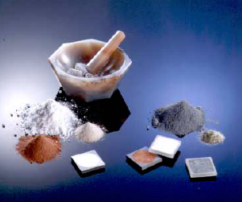
- In order to obtain a diffraction pattern of a mineral you must grind and sieve your sample to <270 mesh and then mount it in the sample holder.
- Mount the powder in the sample.
- Check is sample circle and detector circles are at zero

Operation procedure for PXRD:
- Turn on the power of the spectrometer using the surge protector behind the machine.
- Turn water cooler pump on, and then turn the tap on counter clockwise.
- Press control power on
- Press X-ray off button and check the mA and kV readings they should be 10mA and -10kV.
- Press x-ray power on button.
- Turn the computer on and go to N-T operating system.
- Go to the program DMSNT.
- On the program task bar pull down hardware and go to configuration.
- Make sure the detector and sample omega are set to zero.
- Pull down hardware again and select manual commands and then goniometer.
- Check hardware set next position to 40m then click on Axis power on. After test set back to zero.
- Check the water levels they should be65ºF and 70psi.
- Slowly turn mA and kV readings up using the following intervals. Each interval should be 3 minutes apart. The intervals are as follows mA -10, 16, 22, 28, 35. kV values – 10, 19, 28, 37, 45.
- Prepare the sample and put in the diffractometer and turn off the light.
- At computer open event list and give file name, ID and comment.
- For a normal scan start at 2o angel and stop at 80oangel. Set the scan to continous and set the rate of scan.
- Before scan starts make sure interlock reset light is off.
- Click on go to top to start the scan. When the scan is finished save the file.
- When the entire scan is finished set the axis back to zero.
- Slowly set the mA and kV back to 10 and -10 respectively. Use the same time intervals used in turning them on.
- Turn X-ray power off behind the machine.
- Make sure the machine is thoroughly cooled and turn thewater and the pump off.
- Shut down the computer.
Data Processing: Follow the instrcutions

