Lab. 2 Linear Combination of Atomic Orbitals (LCAO):

VB & MO Theories Atomic Orbitals
Right handed Cartesian coordinate system
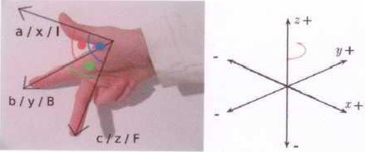
A. Atomic Orbitals
Draw the Angular portion of the wave function of the following atomic orbitals on a right handed Cartesian coordinate system

i) s orbital

ii) 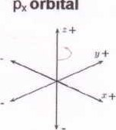
orbital
iii) dz² orbital
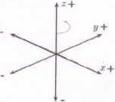
dxz orbital
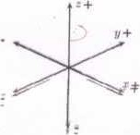
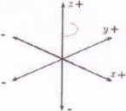
p_{y} orbital p_{z} orbital
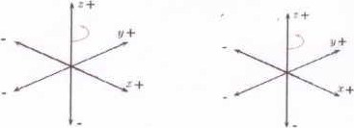
dx²-y² orbital dxy orbital
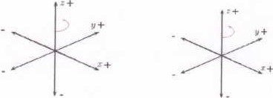
dyz orbital
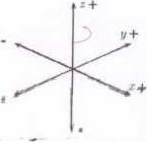

Hybridization of Atomic Orbitals
It is the Linear Combination of Atomic Orbitals (LCAO) in the valance Shell of an atom: Individual wave functions (orbitals) combine to form hybrid atomic orbitals (sp, sp², SP3,sp³d, sp³d²) Quantum mechanical approaches by combining the wave functions to give new wavefunctions are called hybridization of atomic orbitals. Hybridization has a sound mathematical fundation, but it is a little too complicated to show the details here. Leaving out the jargons, we can say that an imaginary rmxing process converts a set of atomic orbitals to a new set of hybrid atomic orbitals or hybrid orbitalsHybrid Atomic Orbital: Combination of atomic orbitals from the same atom
At this level, we consider the following hybrid orbitals:
- Draw hybrid orbitals resulting from sp hybridization
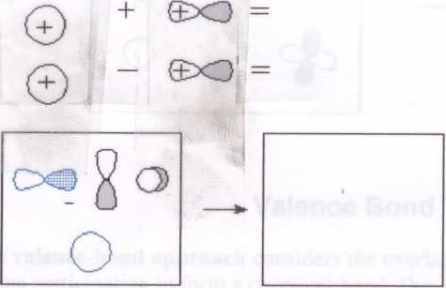
- Draw hybrid orbitals resulting from sp² hybridization
 | 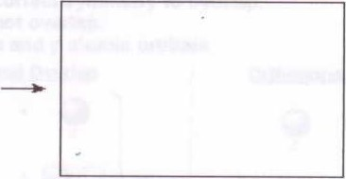
  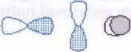
  O
- Draw hybrid orbitals resulting from sp³ hybridization
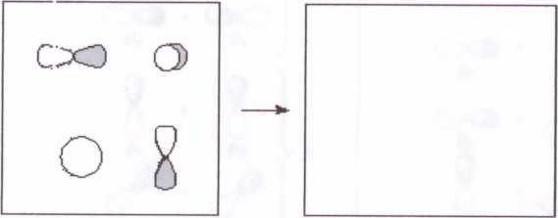

- Draw hybrid orbitals resulting from sp³d hybridization
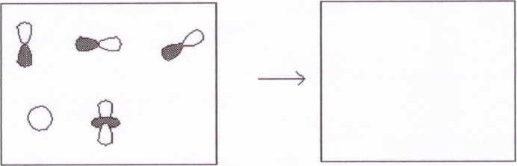
- Draw hybrid orbitals resulting from sp³d hybridization
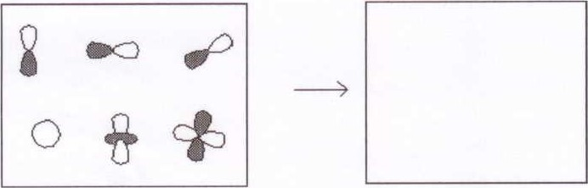

Valence Bond Theory
The valence-bond approach considers the overlap of the atomic orbitals (AO) ofthe two atoms participating to form a chemical bond. Due to the overlapping, electrons are localized in the bond region.

Orbital Overlap
Orbitals must have the correct symmetry to overlap.
Orthogonal orbitals do not overlap.
Overlap involving pure s and p atomic orbitals
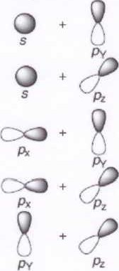
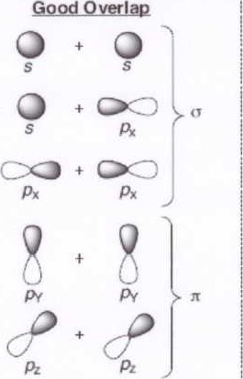 Orthogonal: No Overlap

What is a delta (5) bond? Draw an example.
Show overlap between following atomic orbitlals to from covalent bond

Pure atomic orbitlas
- s-s overlap
- p_{x}- p_{x} overlap
- p_{x}- d_{xy} orbital overlap
- dxz-dxz orbital overlap
Pure atomic orbitlas
- sp-sp overlap
- sp²- sp² overlap
- sp³- sp³ overlap
- sp³d- p overlap
- sp³d²- sp²0rbital overlap bond type:
bond type: bond type: bond type: bond type:
bond type:
4
bond be:
bond type:
bond type:
Draw example
Draw example
Draw example
Draw example
Draw example

Molecular Orbital Theory
In Molecular Orbital Theory, the orbitals undergo the Linear Combination of Atomic Orbitals (LCAO) in a molecule to from molecular orbitals from the overlap of atomic orbitals of the atoms that satisfy two criteria:
- The orbitals have compatible symmetry
- The orbitals are similar in energy
The interactions of the atomic orbitals to form molecular orbitals is represented by an energy diagram called a molecular orbital diagram. The diagram displays the orbitals arranged vertically from lowest to highest energy. The atomic orbitals for the various atoms are listed in columns at the left and right sides of the diagram. The molecular orbitals are listed in a column down the center of the diagram.
The atomic orbitals are given the usual s, PX, etc. designation. The molecular orbitals, which are often identified by their symmetry properties, may be identified by their bonding properties: o, a*, It, rt*, or n (nonbonding).
Antit•onding
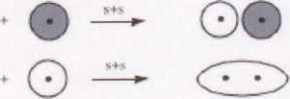
Is G)0* Is
Bonding MO
Is01s
Example H2 molecule
Is 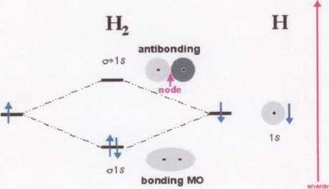
5
bond
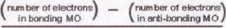
2
2
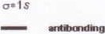 2
I-LIMO
HOMO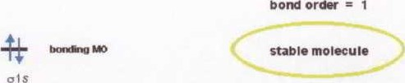
P orbitals linear combinations

2px 0*2px
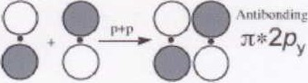
Antit»nding
2py 2pz00 IT*2pz
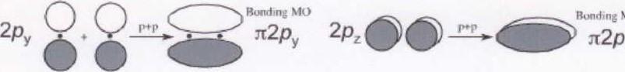
MO
z

MO 2px 02px
A. At this level, we consider the following hybrid orbitals:
- Draw sigma molecular orbitals resulting from s and s linear combination of atomic orbitals
G)
G)
6
- Draw sigmamolecular orbitals resulting from s and p linear combination of atomic orbitals
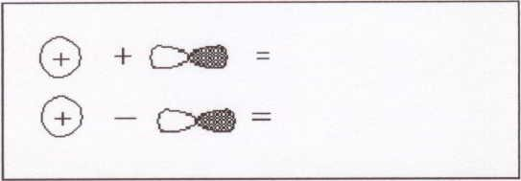
- Draw bonding pi molecular orbitals resulting from p and p linear combination of atomic orbitals
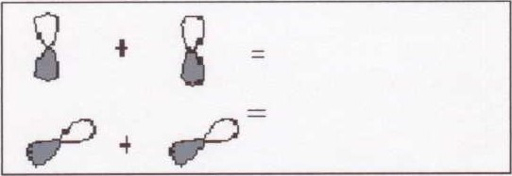
- Draw anti-bonding pi molecular orbitals resulting from p and p linear combination of atomic orbitals
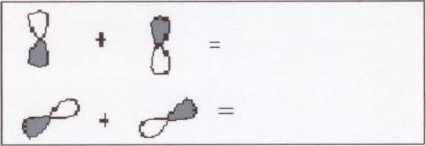
  - Draw molecular orbitals for homonulcear diatomic molecules of the 2nd period elements 02, F2 and Ne2
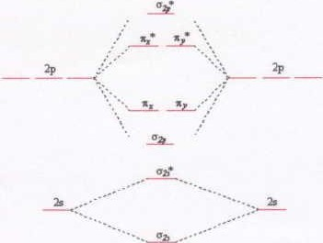
7
  - Draw molecular orbitals for homonulcear diatomic molecules of the 2nd period elements B2, C2 and N2
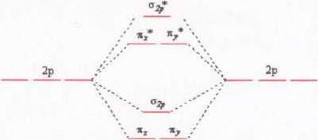
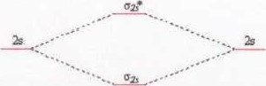
  - Using the molecular orbital digram for the homonulcear diatomic molecules of the 2nd period elements calculate the following:
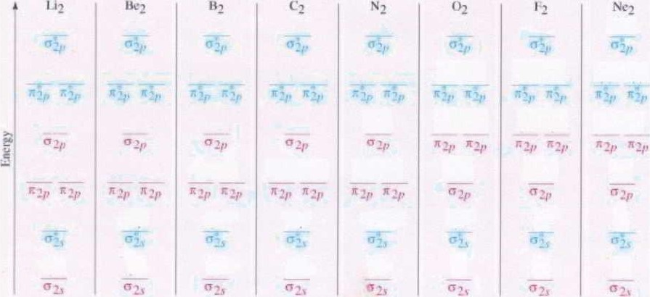
- Number ofvalence electrons in each molecule:

02 =
- Bond order of each molecule:
02 -
- Unpaired electrons in each molecule:
Li2 02 =Ne2=

