CHEM 281 Name:_______________________________
HW 6. Chapter 3. Ionic Solid Structures
Key Questions (relatively simple to answer using the Focus Information)
- Explain the solid state structures of ionic compounds using the concepts applied for solid state metallic structures.
  - Body-centered Cubic (BCC)
- CsCl Structure:

- CaTiO₃ Pervoskite Structure

  - Cubic Close Packing (CCP or FCC)
- Rock Salt Structure:

- Fluorite Structure:

- Sphalerite Structure:
  - Hexagonal Close Packing (hcp)
- Wurtzite:

- Rutile:

- Give coordination number for both anion and cation of the following ionic lattices.
    - CsCl Structure:

    - Rock Salt Structure:

    - Fluorite Structure:

    - Sphalrite Structure:

    - Wurtzite:

    - Rutile:

- Give the number of ions per unit cell of the pervoskite structure of superconducting material (1-2-3:Y-Ba-Cu) given below: 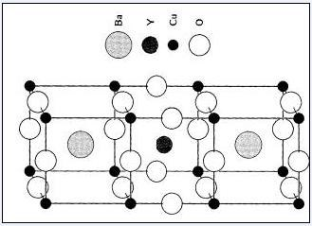

- Explain the factor affecting the ion coordination number in an ionic compound.

- Why, in the study of an ionic lattice, is the anion packing considered to be the frame into which the cations fit?

- Draw the Miller indices of the planes in the sodium chloride structures below:
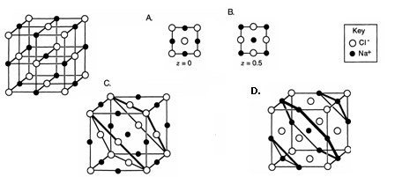

- What is radius ratio rule?

- Suggest the probable crystal structure of (a) barium fluoride; (b) potassium bromide; (c) magnesium sulfide. You can use comparisons or obtain ionic radii from data tables.

- Use a model to draw a partial ionic lattice diagram for the antifluorite structure of lithium oxide

- In a sodium chloride lattice, the ions usually touch along the edge of the unit cell. If the ionic radii are in r+, and r-, calculate the length of each side of the unit cell.

- In a cesium chloride lattice, the atoms usually touch along the diagonal from one corner through the center of the cell to the opposite comer. If the ionic radii are r+ and r-, calculate the length of each side of the unit cell.

- The ions in cesium chloride are arranged in a body-centered cubic unit cell. Calculate the radius of a cesium ion if the density of cesium chloride is 3.97 g-cm⁻³, and it is assumed that the ions touch through the diagonal of the unit cell.

