Louisiana Tech University, Chemistry 281. POGIL(Process Oriented Guided Inquiry Learning) Exercises on Chapter 1. The Atomic Structure
Why?
How chemical elements are created in the Universe? What is nucleosysnthesis? How the lighter and heavier elements are created during nucleosynthesis? What are main types of nuclear reactions? How the binding energy determines the type of nuclear reaction? How the atomic structure was discovered through many experiments starting with alchemy? How do we use Bohr model to describe atomic spectrum of hydrogen and hydrognic atoms? What is the difference between a absorption and emission spectrum? Why did the Bohr model failed to describe atomic spectrum of multi-electron atoms? Why it requires quantum (wave) mechanical models to interpret the atomic spectroscopy of multi-electron atoms? What’s wave particle duality of matter and energy? Why does modern atomic theory treat electron as a wave? What is a quantum mechanical model? What is Schrödinger wave equation? Why is it essential to understand the significance of this equation, wave function and its interpretation? What is a wave function? What are components of wave function? What is radial and angular component of wave function? What are quantum numbers? How is Radial Distribution Function, P_{n}l(r) is related to radial wave function, R_{n}l(r)? What are nodes in a wave function, ø? How many total nodes are in a particular wave function? How do you calculate radial and angular nodes in a wave function? What is Heisenberg uncertainty principle and how is used to give a interpretation of square of wave functions, ø² as a probability of finding electron in a certain region? What’s Born interpretation of the wave function? How a wave function is related to atomic orbitals? What are the ways to the radial and angular components of wave function?
Learning Objectives
Understand the 1) The origin of the elements in the Universe and the earth, 2) The classification of the elements and the periodic table, 3) How atomic structure was discovered, 4) Bohr theory and interpretation of spectra of hydrogonic atom, 5) Wave-particle duality of matter and energy, 6) Principles of quantum mechanics 7) The Schrödinger wave equation and its significance, 7) Wave function and its interpretation, and 8) Shapes and nodes of the atomic orbitals.
Success Criteria Understand
- How are chemical elements created in the Universe?
- The main types of nuclear reactions: Fusion and fission.
- The binding energy in relation to the type of nuclear reaction.
- The experiments 1) cathode-ray tubes 2) Oil drop experiment, 3) Rutherford's a-particle Experiments,4) Moseley's X-ray experiment, 5) Chadwick's bombardment of ⁹Be with a-particles and their importance in finding modern atomic structure.
- The wave properties and Electromagnetic radiation (EMR):
- Bohr model in explaining hydrogen emission spectrum.
- Atomic spectroscopy: a) Emission spectroscopy, b) Absorption spectroscopy
- Importance of photoelectric effect and particle description of electrons

- Wave-Particle Duality of Matter and Energy and wave technical models
- The Schrödinger Wave Equation and Its Significance
- Wave function
- Quantum numbers
- Hisenberg uncertainty principle.
- Born interpretation of the wave function
- Atomic Orbitals and their relation to wave function, their shapes, number nodes
Resources
Inorganic Chemistry By Peter Atkins, Tina Overton, Jon Rourke, Mark Weller, Fraser
Armstrong, 4th Edition 2006.
Prerequisites: Freshman and organic chemistry
What you already know
Early Experiments for Atomic Structure
- J.J. Thompson using cathode-ray tubes or Crook's tubes: Electron
- Millikan’s Oil Drop Experiment: Electronic charge = 1.60 x 10⁻¹⁹ c
- Rutherford's a-particle Experiments: Nucleus
- Moseley's X-ray experiment: Atomic Number (Z) and protons
- Chadwick's bombardment of ⁹Be with a-particles: Neutron
- Wave properties: Wave equation, c = vX; c = velocity of wave,v = frequency of wave, X = wavelength
a) wavelength b) frequency c) speed
d) amplitude e) constructive interference f) destructive interference
g) reflection h) refraction i) diffraction of waves.
- Electromagnetic radiation (EMR):
- Radiation profiles emitted by hot solid bodies: E = h v
- Photoelectric effect: a) Quantum b) Photon
- Wave-Particle Duality of Matter and Energy: E = mc² (Einstein) and X = h/mv (de Broglie)
- Bohr model
Energy of the electron in orbit n (E_{n}):
E_{n} = -2.178 x 10⁻¹⁸ J (Z²/n²); E_{n} = -2.178 x 10⁻¹⁸ J 1/n² Z= 1 for hydrogen
Energy changed is given by: ∆E = Ef - Ei or ∆E = -2.178 x 10⁻¹⁸ [1/n² _{f} - 1/n²i] J Paschen Series: nf=3... ni = 4,5,6,7 Balmer Series: nf=2... ni = 3,4,5,6,7 Lyman Series: nf=1... ni = 2,3,4,5,6,7
- Atomic spectroscopy: c) Emission spectroscopy d) Absorption spectroscopy
- Hisenberg uncertainty principle. The position and momentum of a particle cannot be simultaneously measured with arbitrarily high precision. 13) Wave - mechanical model of atom
- Quantum numbers
In wave mechanics there are rules to obtain Quantum numbers: n value could be 1, 2, 3, 4, 5, . . . . Etc.
l values depend on n value: can have 0 . . . (n - 1) values ml values depends on l value: can have -l . , 0 . . . +l values of ml m_{s} should always be -1/2 or +1/2
- Sub-levels: s, p, d, and f sub-levels (different l values)

16) Periodic table: Long form and orbital blocks (s, p, d and f)
New Concepts
The origin of chemical elements in the Universe
Binding energy of an isotope
The binding energy of a nucleus is a measure of how tightly its protons and neutrons are
held together by the nuclear forces. The binding energy per nucleon, the energy required
to remove one neutron or proton from a nucleus, is a function of the mass number A.
(∆m) = Mass of Nuclide - Mass of (p + n +e )
Proton mass: 1.00728 amu
Neutron mass: 1.00867 amu
Mass defect (∆m), then multiply by 931.5 MeV/amu
Fusion and Fission nuclear reactions
- Fission: Nuclear fusion is the process of fusing or combining atoms.
- Fission: Nuclear fission is the process of splitting atoms.
The nucleosysnthesis reactions
The nuclear reaction that are taking place in universe to produce elements.
Nucleosynthesis of lighter and heavier elements
Lighter elements: Are produced inside stars using fusion nuclear reactions of elements
which have atomic number less that 26 (Fe).
Heavier elements: Elements with atomic number greater that 26 Fe) are produced
during supernova explosion of stars using neutron capture reactions followed by nuclear
fission reactions.
Eight Steps in the History of the Earth
1. The Big Bang
2.Star Formation
- Supernova Explosion
- Solar Nebula Condenses
- Sun & Planetary Rings Form
- Earth Forms
- Earth's Core Forms
- Oceans & Atmosphere Forms The classification of elements
- Dobereiner Triads
- Newlands called the Law of Octaves
- Lothar Mayer’s atomic volume curves
- Mendeleyev’s periodic table
- Modern Periodic Table Existence of the Elements
Origin of elements
How did these elements come into being; from what primordial stuff were they made? Big Bang theory explains the creation of the Universe with a explosion followed by formation of galaxies, stars and planets. Stars and supernova explosions are the place of creation of atoms of all elements through fusion reactions followed by fission nuclear reactions. Formation of certain nuclei could be explained based on the their stability
Stability of the Elements and Their Isotopes
P/N ratio of nucleus

For stable lighter elements P/N ration seem to equal to 1. As the number pf
protons increased repulsion is increased and number of neutrons seem to increase to
offset the repulsion. However, eventually nuclei become too unstable.
Nuclear Binding energy per nucleon
Mass defect (∆m) = Mass of Nuclide - mass of (p + n +e )
Proton mass: 1.00728 amu
Neutron mass: 1.00867 amu
Nuclear binding energy = (∆m amu x 931.5 MeV/amu)/ number of nucleons(# of p +n)
Magic Numbers
Nuclei with either numbers of protons or neutrons equal to N =2, 8, 20, 28, 50, 82, or 126
more stable analogous to the stability of closed shell electrons in atoms.
Periodic Classifications of the Elements
Development of Periodic Table
Dobereiner Triads: Certain elements, which had similar chemical properties, could be grouped together. When these elements were arranged in increasing order of their atomic masses, they generally occurred in groups of three. The atomic mass of the middle element of the triad, is nearly equal to the arithmetic mean of the atomic masses of the other two elements of the triad.
 |  | Dobereiner Triads
Cl | 35.5 | Li | 7 | S | 32
Br | 79 | Na | 23 | Se | 79
I | 127 | K | 39 | Te | 128
Newlands’ Law of octaves: Newland was the first to detect a periodic pattern in the properties of the elements and anticipated later developments of the periodic law when certain chemical elements are arranged according to increasing atomic weight, those with similar physical and chemical properties occur after each interval of seven elements.
Octaves 1 Li Be B C N O F
Octaves 2 Na Mg Al Si P S Cl
Lothar Mayer’s atomic volume curves
Lothar Meyer determined the atomic volumes of elements. If the atomic volumes of the elements were plotted against the atomic weight, a series of peaks were produced. The peaks had alkali metals: sodium, potassium, rubidium, and cesium. Each fall and rise to a peak, corresponded to a period like the waves.
Mendeleev’s periodic table
Lothar Meyer made important contributions to the first Periodic Table but the main credit goes to Mendeleev. He listed elements in order of increasing atomic weight while trying to maintain periodicity of Newlands. He left spaces for elements that were not yet discovered but he predicted properties of these elements and their compounds.
Modern periodic table
The modern periodic table of elements is an improvement of Mendeleev's table organized by atomic number (z) instead if atomic weight and it also reflect the atomic structure more directly with periods corresponding to pricipale QN and s, p, d and f atomic orbitals.

I II IIIb IVb Vb VIb VIIb VIIIb Ib IIb III IV V VI VII 0
1 2 3 4 5 6 7 8 9 10 11 12 13 14 15 16 17 18
The Schrödinger Wave Equation and Its Significance


Sc
Ti
V
Cr Mn Fe
Y
Zr
Tc
Ru
Nb Mo
Hf
Ta
W
Re
Os
La*
Ac** Rf
Db
Sg Bh Hs
Sm
Pu
H
Li
Na
K
Rb
Cs
Fr
Be
Mg
Ca
Sr
Ba
Ra
He
Lanthanides *
Actinides **
Nd
Pm

No
Fm Md
Zn
Cd
Uub
Dy
Cf
B
Al
Ga
In
Ho
Es
C
Si
Ge
Sn
Pb
Uuq
Er
N
P
As
Sb
Bi
Hg Tl
Tm Yb
Co
Rh
Ir
Mt
Eu Gd
Am Cm
Cu
Pd Ag
Au
Uuu
Tb
Bk
Ni
O
S
Se
Te
Po
Uuh
Ne
Ar
Kr
Xe
At Rn
Uuo
Lu
Lr
F
Cl
Br
I
Pt
Uun
Ce
Pr
Th
Pa
U Np
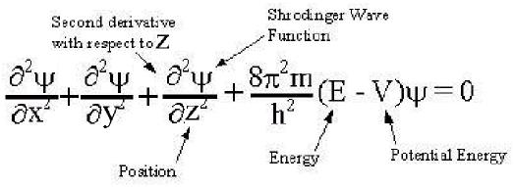
ψ = wave function, E = total energy, V = potential energy
Each electron can be described in terms of Wave function ø its quantum numbers. (n, l,
ml, m_{s}),
ψ2 is proportional to probability of finding the electron in a given volume.
Max Born Interpretation: ø² = atomic orbital ( region finding an electron is highest)
Mathematical expression of hydrogen like orbitals in polar coordinates:
ψn, l, ml, ms (r, 9, 4) = R n, l (r) Y l, ml (9, 4);
R n, l (r ) = Radial Wave Function; Y l, ml (9, 4) =Angular Wave Function
Nodes are where ø = 0: They could be a point, planes cones or shells
Nodes in the øn, l, ml, ms
Total nodes = n -1
Radial nodes = n -1- l
Angular nodes = l

Radial Distribution
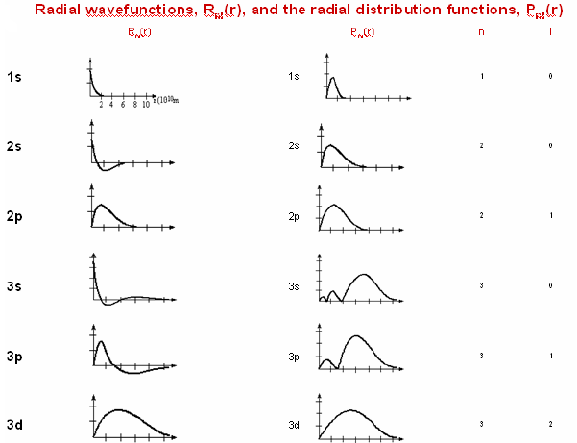

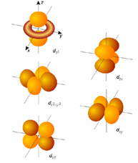

Shapes of the Atomic Orbitals: See text book chapter 1.
Functions of Atomic Orbitals
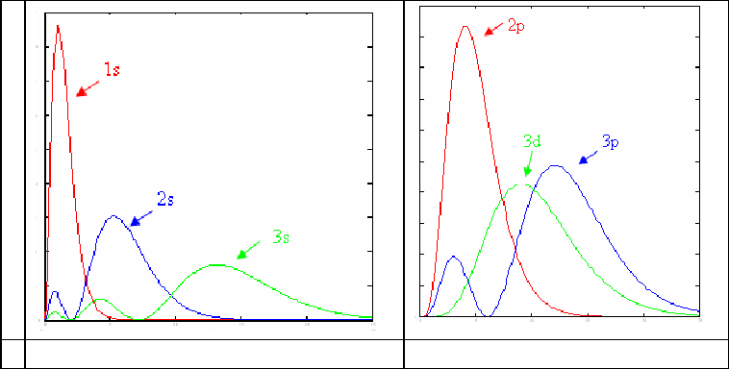
Effective nuclear charge (Zeff): Zeff is the nuclear charge felt by an electron in a multielectron atom.
- In an atom each electron has different Zeff.
- It is less than atomic number (Z) since electrons screen each other from the nucleus.
- Zeff also depends on how far an electron is from nucleus the atomic radius.
- Depends on orbital type the electron is in: Zeff of 4s > 4p > 4d > 4f.
Screening (shielding) constant (σ): Is the screening constant for each electron calculated based on the principle quantum number, orbital type and penetration and of all other electrons in an atom.
Zeff = Z - σ; Z is the atomic number.
Penetration of an electron:
Comparing orbitals within same shell (or principle QN), we say that the s orbital is more penetrating than the p or d orbitals, meaning that an electron in an s orbital has a greater chance of being located close to the nucleus than an electron in a p or d orbital. For this reason, electrons in an s orbital have a greater shielding power than electrons in a p, d or f orbital of that same shell.

GHW # 1: Chapter 1- Your Name:__________________________________________
Key Questions (relatively simple to answer using the Focus Information)

      - What is a nucleosysnthesis reaction?
- What are following nucleosysnthesis reactions?
- Fusion
- Fission

- What is the binding energy of an isotope and how it is calculated?

- Calculate the binding energy per nucleon (MeV) of ⁵⁶Fe isotope of mass 55.952918 amu. ( P= 1.007277 amu, N= 1.008665 amu)

- How is the chemical elements are created in the Universe?
- Complete the following Nuclear reactions:
- Uranium – 238 decays by alpha radiation to produce what other element?
- Thorium – 234 decays by beta radiation to what other element?
- What element did we start out with if the result of beta decay is bismuth– 214?
- What element is produced when mercury – 201 captures an inner shell electron with the production of a gamma ray to release excess energy?

- What are theories that have been used to describe the nuclear stability?
- How long would it take for a sample of 222Rn that weighs 0.750 g to decay to 0.100 g? Assume a half-life for 222Rn of 3.823 days?

- Describe the Nucleosynthesis of
- Lighter Elements
- Heavier Elements
- What are the Eight Steps in the History of the Earth?

- Why is comic abundance different from terrestrial abundances?

GHW # 2: Chapter 1- Your Name:__________________________________________
Key Questions (relatively simple to answer using the Focus Information)

- What was discovered and the significance of each experiment:
- J.J. Thompson using cathode-ray tubes or Crook's tubes:

- Millikan’s Oil Drop Experiment:

- Rutherford's a-particle Experiments:

- Moseley's X-ray experiment:

f) Chadwick's bombardment of ⁹Be with á-particles
- (Spectroscopic Information) What are following series of lines in hydrogen emission spectrum?
- Paschen
- Blamer
- Lyman
- Brakett

- What is Bohr model of atom?

- Calculate the wavelength of light that can excite the electron in a ground state hydrogen atom to n = 7 energy level.

- Why was a wave mechanical model required to describe the arrangement of electrons around the nucleus of an atom?

- What are the characteristics of waves?
- What is a standing wave?
- What is electromagnetic radiation (EMR)?
- What is wave-particle duality of matter and its significance?

- What is Schrödinger Wave Equation and Its Significance to atomic structure?

- Describe the sub-level in the n= 4 energy level with l= 2.

- Degeneracy of following sub-levels:
i) s-sub-level: ii) p-sub-level: iii) d-sub-level: iv) f-sub-level:

- How many angular nodes are in 2p, 3p and 3d orbitals?
- Draw the boundary surface of s, p_{x}, p_{y} and p_{z} orbitals and identify the angular nodal planes.
- What is:
- Wave function?
- Heisenberg uncertainty principle and significance to atomic structure?
- Max Born interpretation of wave function?
- Nodal surface?
- d) Atomic orbitals?
- Construct a quantum number tree for the principal quantum number n = 5

- Identify the orbital that has n = 5 and l = 1,
- Describe the radial and angular component of a wave function.
- Explain the general rule used to find the number of radial and angular nodes of a wave function.
- Nodes in a 4d orbital:
- Total nodes =
- Radial nodes =
- Angular nodes =

- Plots of radial probability function: [R n, l (r )]² Vs r (radius) for various n and l values
- n =2 and l =0
- n =3 and l =1
- Describe the classification of elements in the Mendeleyev’s periodic tables.
- Describe the classification of elements in the modern periodic tables.

- What is Effective Nuclear charge of an electron in a multi-electron atom?

- Penetration & Shielding of an Electron in multi-electron atom and how does it affect the filling order as given by “Building Up” principle?

