**Test 1. Allowed Material**

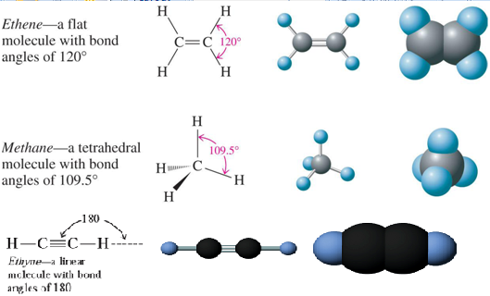

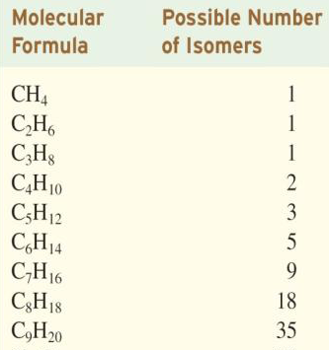

**Unsymmetric Addition Reactions**:

**Markovnikov’s Rule**: When an unsymmetrical molecule HQ (e.g., H-Cl, H-OH, H-F) reacts with an unsymmetrical alkene, the hydrogen atom from the HQ becomes attached to the unsaturated carbon atom that already has the most hydrogen atoms