**Chapter 18: Carbohydrates**

**Instructional Objectives**

1. Know the difference between complex and simple carbohydrates and the amounts of each recommended in the daily diet.
2. Know the difference between complex and simple carbohydrates and the amounts of each recommended in the daily diet.
3. Understand the concepts of chirality, enantiomers, stereoisomers, and the D and L-families.
4. Recognize whether a sugar is a reducing or a nonreducing sugar.
5. Discuss the use of the Benedict's reagent to measure the level of glucose in urine.  Draw and name the common, simple carbohydrates using structural formulas and Fischer projection formulas.
6. Given the linear structure of a monosaccharide, draw the Haworth projection of its a- and 0-cyclic forms and vice versa.  Discuss the structural, chemical, and biochemical properties of the monosaccharides, oligosaccharides, and polysaccharides.
7. Know the difference between galactosemia and lactose intolerance.

**Introduction**

In this chapter on carbohydrates, we will focus our attention almost exclusively on biochemistry, the chemistry of living systems. Like organic chemistry, biochemistry is a separate branch of chemistry, and in an introductory course we can only discuss only the fundamentals. The approach to biochemistry is similar to the approach we took in organic chemistry in chapters 12 through 17 dealing with fundamentals of simple organic molecules: hydrocarbons, alcohol, ethers, aldehydes, ketones, amines and carboxylic acid and their derivatives. Likewise individual chapters 18 thorough 23 will discuss the major classes of biochemical compounds, which are carbohydrates, lipids, proteins, and nucleic acids. Last few chapters 24 through 26 will deal mainly with the major types of chemical reactions, ATP and synthesis and degradation og biomolecules in living organisms: the metabolism.

In this chapter we discuss the fundamentals of carborhydrates. The same functional groups found in organic compounds are also present in biochemical compounds. Usually, however, there is greater structural complexity associated with biochemical compounds as a result of polyfunctionality: several different functional groups are present. Often biochemical compounds interact with each other, within cells, to form larger structures. But the same chemical principles and chemical reactions associated with the various organic functional groups that we have studied apply to these larger biomolecules as wall

**18.1 Biochemistry--An Overview**

Biochemistry is the study of the chemical substances found in living organisms and the chemical interactions of these substances with each other. It deals with the structure and function of cellular components, such as proteins, carbohydrates, lipids, nucleic acids, and other biomolecules.

There are two types of biochemical substances: bioinorganic substances and

**Inorganic substances**: water and inorganic salts.

**Bioorganic substances**: Carbohydrates, Lipids, Proteins, and Nucleic Acids.

**Complex bioorganic/inorganic Molecules**: Enzymes, Vitamins, DNA, RNA, and Hemoglobin etc.

As isolated compounds, bioinorganic/bioorganic/complex substances have no life in and of themselves. Yet when these substances are gathered together in a cell, their chemical interactions are able to sustain life.

**Plant Materials**

It is estimated that more than half of all organic carbon atoms are found in the **carbohydrate materials** of plants. Human uses for carbohydrates of the plant kingdom extend beyond food. Carbohydrates in the form of cotton and linen are used as clothing. Carbohydrates in the form of wood are used for shelter and heating and in making paper.

**18.2 Occurrence and Functions of Carbohydrates**

Almost 75% of dry plant material is produced by photosynthesis. Most of the matter in plants, except water, are carbohydrate material. Examples of carbohydrates are cellulose which are structural component of the plants, starch the energy reservoir in plants and glycogen (animal starch) found in animal tissues and human body in smaller quantities. Plant products are the major source of carbohydrates and average human diet contains 2/3 of carbohydrates. Recommended percents in the daily diet:

**Recommended carbohydrates ~ 60 %**

**Recommended sucrose less than 10%**

**Usefulness of carbohydrates** is their ability to **produce energy** when they under go oxydation during respiration. **Storage carbohydrate**, in the form of glycogen, provides a short-term energy reserve for bodily functions.

Carbohydrates supply carbon atoms for the synthesis of other biochemical substances (proteins, lipids, and nucleic acids). Carbohydrates also form a part of the **structural framework of DNA and RNA** molecules. Carbohydrates linked to lipids as discussed in Chapter 19 are structural components of **cell membranes**. Carbohydrates linked to proteins as discussed in Chapter 20 function in a variety of cell–cell and cell–**molecule recognition processes** as useful markers forantibodies.

**18.3 Classification of Carbohydrates**

Organic compounds containing many -OH groups (polyhydroxy), and aldehydes or ketones functional groups. By convention, the ending "-ose" is reserved for sugars (e.g. sucrose and glucose)  in the class of carbohydrates.

Carbohydrates are produced by the process of photosynthesis in which six carbon sugars or hexoses are produced using energy of sunlight, green pigment chlorophyll, CO2 and H2O by green plants. The hexoses produced are the raw material for the biosynthesis of glycogen, fats, proteins and nucleic acid in living systems.

**Simpler Formula for Cabohydrates:**

* + **CnH2nOn** or Cn(H2O)n (hydrates of C)
  + n= number of atoms

**Monosaccharides**

They consist of one sugar containing 3,4,5,6 and 7 carbon atoms and are usually colorless, water-soluble, crystalline solids. Some monosaccharides have a sweet taste. Examples of monosaccharides include glucose (dextrose), fructose (levulose), galactose, xylose and ribose.

**Disaccharides**

a sugar (a carbohydrate) composed of two monosaccharides.

Oligosaccharide

An oligosaccharide is a saccharide polymer containing a small number (typically 3-10 monosaccharides

**Polysacharides**

Are relatively complex carbohydrates. They are polymers made up of many monosaccharides joined together by glycosidic bonds. They are insoluble in water, and have no sweet taste.

**Monosaccharide structures and types**

**Aldoses** :Aldehyde sugars are called aldoses.

**Ketoses**: Ketone sugars are called ketoses.

**Drawing Sugar** **Molecules**

* **Linear structure-Fischer projection of a monosaccharide**

**Aldose** **Ketose**

* **Haworth projection** showing cyclic forms: - and - forms.

The normal form of most sugars is in a **cyclic hemiacetal form** shown as a Haworth projection. In solution, less than 1% of a sugar will be in the linear  form as shown in **Fischer structure** below on the right. In solution, over 99% of the sugar will be in a cyclic ring structure which is represented by **Haworth structures** on the left.  The preferred form varies from sugar to sugar:  some prefer to be a 6-member ring "pyranose", like glucose.

The cyclic ring structures of sugars are formed by the intramolecular hemiacetal formation as we described in Chapter 15.

**ALDEHYDE sugar** or aldoses  + alcohol  --- hemiacetal (cyclic ring)

**KETONE sugar** or ketoses  + alcohol  --- hemiketal (cyclic ring)

They are polyhydroxy aldehydes (sucah as glucose)or ketones (such as fructose) or compounds that produce such substances upon hydrolysis.

**Sugars are classified according to their structures**: according to number of carbon atoms in the sugar and number of sugar units/molecule in a polymer formed by the glycosidic bonds.

**Number fo carbon atoms**

* **Triose** sugar units containing three carbon atoms
* **Tetroses** sugar units containing four carbon tomsa
* **Pentoses** sugar units containing five carbon atoms
* **Hexoses** sugar units containing six carbon atoms

**Steps for drawing Fischer structures of sugars:**    
A monosaccharides can be "sorted" according to the length of the carbon chain in the sugar unit.

1. write the carbon chain vertically with the aldehyde or ketone group toward the top of the chain.

2. number the carbons.

3. place the aldehyde or ketone group.

4. place H and OH groups.   
5. identify the chiral centers.   
6. note the highest numbered chiral center to distinguish D and L sugars.   
7. write the correct common name for the sugar.

**Aldose-Trioses**

**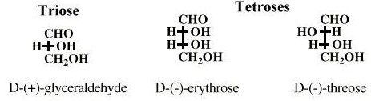**

**Hexoses**

**Mnemonics for remembering sugar names**

**All(allose) altruist (altrose) gladly (glucose) make (mannose) gumbo (gulose) in (idose) gallon (galactose) tanks (tallose)**

**Number fo sugar units**

* **Saccharide**- (derived from Latin for sugar) is the chemical name for a sugar unit:
* **Monosaccharide** (one sugar unit);
* **Disaccharide** (two sugar units);
* **Oligosaccharide** (2 to 10 sugar units);
* **Polysaccharide** (over 10 sugar units).

**Monosaccharides** also can be named based on their functional groups.

**Aldoses**: Monosaccarides with aldehyde functional group. E.g. D-glucose   
**Ketoses**: Monosaccarides with keto functional group. E.g. D-fructose

**Simple carbohydrates: Monosaccharide** and **Disaccharide** ofsimple sugars such as glucose or fructose. **Disaccharide** are two monsaccharides connected by a bridging O atom called a glycosidic bond  as in sucrose.   
**Glycosidic bond**- covalent bond between a hemiacetal or hemiketal and an alcohol.   
Glycoside- compound formed when a sugar in the cyclic form is bonded to an alcohol through a glycosidic bond to another sugar molecule as shown below.

**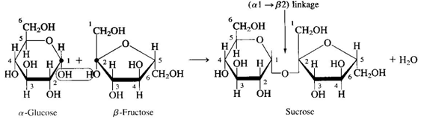**

**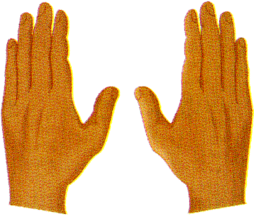  
18.4 Chirality: Handedness in Molecules**

Most monosaccharides exist in two forms: a “**left handed**” and “**right handed**” form - same as two hands

**Two types of objects**:

- **Superimposible on their mirror images**: -- images that coincide at all points when the images are laid upon each other -- a dinner plate with no design features -- Achiral

- **Non-superimposible on their mirror images**: Chiral (handedness)

****

**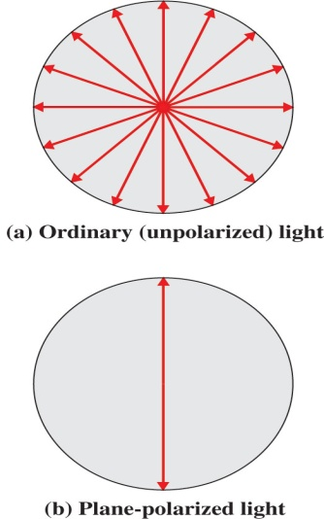Properties of light**

* + Ordinary Light: Move in all directions
  + Plane polarized light move only in one
  + direction (see Figure on right below)

Plane polarized light is rotated clockwise

(to right) or counterclockwise (to left) when passed through enantiomers

Direction and extent of rotation will depend upon the enantiomer

Same concentration of two enantiomers rotate light to same extent but in opposite direction

The way to tell apart the handedness of a molecule is to expose them to plane polarized light

**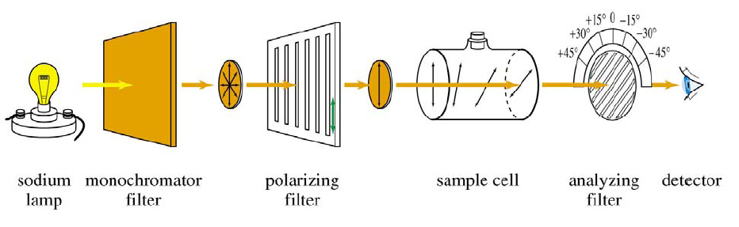**

Light is passed through a polarized filter. A solution of an optical isomer will rotate the light one direction.

**Classification of the molecule based on the rotation of plane-polarized light.**

**Dextrorotatory** - rotate clockwise shown using **(+)** symbol or

- usually **D** isomers

**Levorotatory** - rotate anti-clockwise shown using **(-)** symbol or

- usually **L** isomers

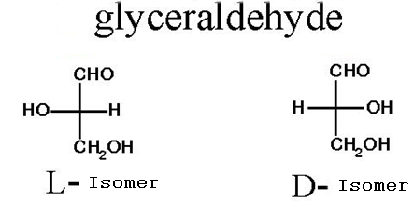

**18.5 Stereoisomerism: Enantiomers and Diastereomers**

Stereoisomers are isomers that have the same molecular and structural formulas but differ in the orientation of atoms in space. There are two types:

**Enantiomers:** They are **stereoisomers** whose molecules are **non-superimposable** mirror images of each other. Molecules with chiral center.

**Diastereomers:**  They are stereoisomers whose molecules are not mirror images of each other. They have more than one chiral centers. Diastereomers (or diastereoisomers) are stereoisomers that are not enantiomers (non-superposable mirror images of each other). Diastereomers can have different physical properties and different reactivity. In another definition diastereomers are pairs of isomers that have opposite configurations at one or more of the chiral centers but are not mirror images of each other.

**Example**

Tartaric acid contains two asymmetric centers, but two of the "isomers" are equivalent and together are called a meso compound. This configuration is not optically active, while the remaining two isomers are D- and L- mirror images, *i.e.*, enantiomers. The meso form is a diastereomer of the other forms.

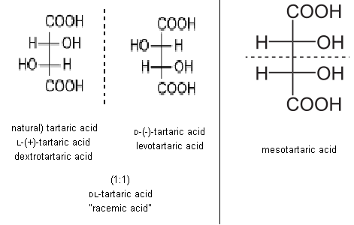**18.6 Designating Handedness Using Fischer Projections**

**Fischer projection formulas** - a method for giving molecular chirality specifications in two dimensions. *A Fischer projection formula* is a two-dimensional structural notation for showing the spatial arrangement of groups about **chiral centers** in molecules.

The four groups attached to the atom at the chiral center assume a tetrahedral geometry and it is governed by the following conventions

Vertical lines from the chiral center represent bonds to groups directed into the printed page. Horizontal lines from the chiral center represent bonds to groups directed out of the printed page.

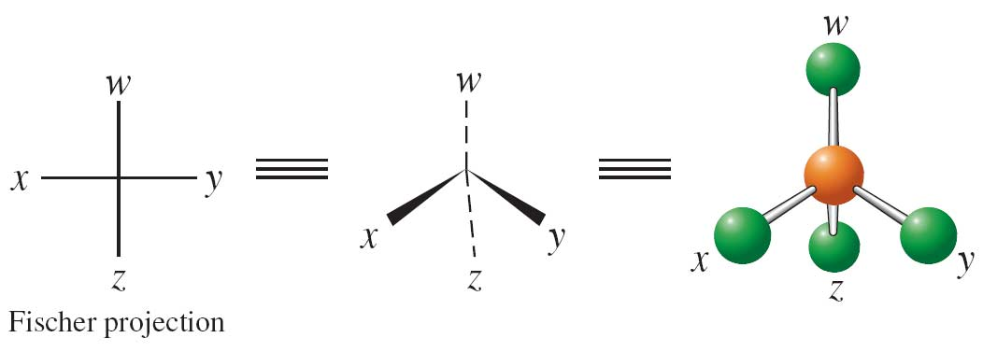

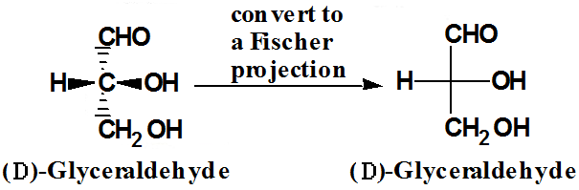

In a Fischer projection formula a chiral center (Carbon) is represented as the intersection of vertical and horizontal lines Functional groups of high priority will be written at top D and L system used to designate the handedness of glyceraldehyde enantiomers.

**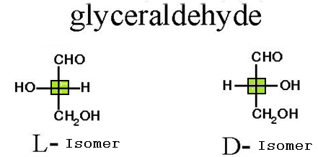**

**18.7 Properties of Enantiomers**

As the right and left handed baseball players can’t use same glove (chiral) but can use same hat (achiral) molecules behaves similarly.

**Enantiomers:** They are optically active: Compounds that rotate plane polarized light

* Two members of enantiomer pair (chiral) react differently with other chiral molecules thus only one will fit into a enzyme.
* Enantiomeric pairs have same solubility in achiral solvents like ethanol and have different solubility in chiral solvent like D-2-butanol.
* Enantiomers have same boiling points, melting points and densities - all these are dependent upon intermolecular forces and chirality doesn’t depend on them..
* Our body responds differently to different enantiomers:
* One may give higher rate or one may be inactive

**Example:** Body response to D form of hormone epinephrine is 20 times greater than its L isomer.

**18.8 Classification of Monosaccharides**



**Triose** --- 3 carbon atoms

**Tetrose** -- 4 carbon atoms

**Pentoses** – 5 carbon atoms

**Hexoses** -- 6 carbon atoms

**Aldoses**: Monosaccharides with one aldehyde group

**Ketoses**: Monosaccharides with one ketone group

**Combined** # of C atoms and functional group:

Example: Aldohexose: Monosaccharide with aldehyde group and 6 C atoms

**Aldohexose**: Monosaccharide with aldehyde group and 6 C atoms – D-glucose

**Ketohexose**: Monosaccharide with aldehyde group and 6 C atoms – D-fructose

**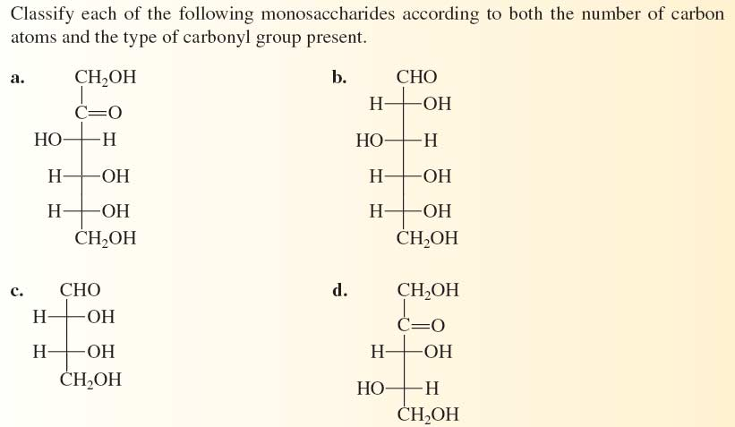**

**570_02**

**18.9 Biochemically Important Monosaccharides**

**Glucose**

Glucose is the most common monosaccharide consumed and is the circulating sugar of the bloodstream. Insulin and glucagon regulate blood levels of glucose



1. Most abundant in nature

2. Nutritionally most important

3. Grape fruit good source of glucose (20 - 30% by mass) -- also named grape sugar, dextrose and blood sugar (70 - 100 mg/100 mL of blood)

4. Six membered cyclic form

**Fructose**

Fructose is slightly sweeter than glucose. It is an intermediary in metabolism and is found in many fruits.



1. Ketohexose

2. Sweetest tasting of all sugars

3. Found in many fruits and in honey

4. Good dietary sugar-- due to higher sweetness

5. Five membered cyclic form

****

**Galactose**

Galactose, a component of lactose (milk sugar) is also found in some plant gums and pectins. Galactosemia results from inability to metabolize galactose. If treated, galactosemia can be managed medically. Untreated galactosemia may result in mental retardation, liver damage, or death.

1. Milk sugar
2. Synthesize in human
3. Also called brain sugar-- part of brain and nerve tissue
4. Used to differentiate between blood types
5. Six membered cyclic form

**Ribose**

Ribose are aldopentose components of RNA

1. Part of RNA

2. Part of ATP

3. Five membered cyclic form

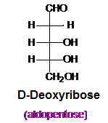

**Deoxyribose**

Deoxyribose are aldopentose components of DNA

1. Part of DNA

2. Five membered cyclic form

**18.10 Cyclic Forms of Monosaccharides**

2 forms of D-glucose:

* + **Alpha**-form: -OH of C1 and CH2OH of C5 are on opposite sides
  + **Beta**-form: -OH of C1 and CH2OH of C5 are on same sides



**18.11 Haworth Projection Formulas**

As useful as the Fischer projection is (it is an excellent way to keep track of relative stereochemistry), it gives a poor sense of the real structure of carbohydrates.   (See Hemiacetal Formation in chapter 15.)  The Haworth projection is a way around this limitation that does not require you to try to convey the complete 3D image of the molecule.   
Sugars in Haworth projection can be classified according to the "ring size" (**five**- **furanoses** or **six**-**pyranoses** ) which they assume in solution.  A sugar with fewer than five carbons can not form a stable ring.

**Furanoses**   
We divide Haworth projections into two classes: furanoses and pyranoses. The furanoses  or 5-member ring hemiacetals  are drawn with the oxygen at the top of a pentagon.  The horizontal bond at the bottom is assumed to be coming out of the plane toward you.   Thus, the five-member ring is in a plane perpendicular to the page.  Vertical lines are drawn on each carbon to indicate attachements above and below the plane of the 5-member ring.  In solution, fructose, ribose, and deoxyribose will exist as five member furanose rings.  The furanose ring resembles the cyclic ether called furan. A furanose form of the sugar ribose is a good example:

**Pyranoses**   
6-member rings ("pyranoses") have a slightly different but quite similar Haworth projection.  A hexagon is placed so that one   
horizontal bond runs along the bottom.  The oxygen in the ring is placed at the upper right.  Usually, the hemiacetal carbon (the   
anomeric position) is placed at the extreme right.   In solution, glucose, galactose, and mannose will exist as six member pyranose rings.  The sugar ring resembles the cyclic ether called pyran. Again, the bond at the bottom is assumed to be coming out of the plane and  vertical bonds are used to indicate substituents above and below the 6-member ring.

**Rules for converting a Fischer  structure to a Haworth structure.**

1. draw either a pyranose or a furanose ring depending on the sugar.   
2. attach "flagpole" carbon above the ring and number the carbons.   
3. attach -OH and -H groups using the conventions below:   **Fischer**                     **Haworth**   
      -OH to right            -OH down (below ring)   
  -OH to left              -OH up (above ring)

For  **-anomer**, place the anomeric carbon -OH "opposite" the flagpole carbon.

For  **-anomer**, place anomeric carbon -OH "same side" as the flagpole carbon.

**Anomeric carbon**- the new chiral center created when the sugar ring is formed.

**Anomers**- the two new sugar stereoisomers created by ring closure.

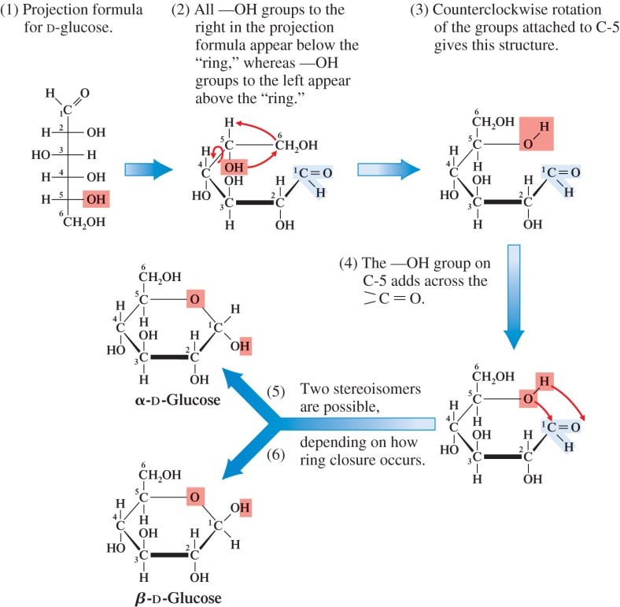

**Practice Exercise**

Which of the monosaccharides glucose, fructose, galactose, and ribose has each of the following structural characteristics? (There may be more than one correct answer for a given characteristic)

* 1. It is a pentose.
  2. It is a ketose.
  3. Its cyclic form has a 6-membered ring.
  4. Its cyclic form has two carbon atoms outside the ring.

**Answers:**

**a. Ribose b. Fructose c. Glucose, galactose d. Fructose**

**18.12 Reactions of Monosaccharides**

Five important reactions of monosaccharides:

* + Oxidation to acidic sugars
  + Reduction to sugar alcohols
  + Glycoside formation
  + Phosphate ester formation
  + Amino sugar formation

These reactions will be considered with respect to glucose. Other aldoses, as well as ketoses, undergo similar reactions.

1. **Oxidation to acidic sugars**  
   **Reducing sugars**- a sugar aldehyde or ketone which can be oxided to an acid and drive the reduction of a metal ion. Oxidation can yield three different types of acidic sugars depending on the type of oxidizing agent used:

Weak oxidizing agents such as Tollens and Benedict’s solutions oxidize the aldehyde end to give an aldonic acid.

A reducing sugar is a carbohydrate that gives a positive test with Tollens and Benedict’s solutions.  
Aldehyde sugars should  show positive test for the Benedict's test because of the aldehyde functional group in the molecule.   
**Benedict's Test for aldehydes:**   
  
Oxidation can yield three different types of acidic sugars depending on the type of oxidizing agent used:

Weak oxidizing agents such as **Tollens** and **Benedict’s** solutions oxidize the aldehyde end to give an **aldonic acid**.

A reducing sugar is a carbohydrate that gives a positive test with Tollens and Benedict’s solutions.

However, keto sugars also gives a positive test for Benedict's test because keto sugars could be converted to aldehyde sugars through the enediol intermediate under the reaction conditions. Therefore,  all **monosaccarides** both **aldoses and ketoses** show a positive behavior in the Benedict's test. and considered as **reducing sugars.**  In biological systems keto form of aldehyde sugars (aldoses) are converted to ketone sugars (ketoses) via enediol (enol) froms as shown below. Therefore D-fructose which is a ketone or keto sugar (ketose) will give a positive test for Benedict's test because of the ability of ketoses to get converted to aldoses (aldehydes).   
  
**Use of the Benedict's reagent to measure the level of glucose in urine.**   
This test have been used in old days to detect excess boold sugar in diabetic patients. This test shows positive behavior for all reducing sugars which includes maltose and lactose and therefore not an very good test for glucose in the urine.

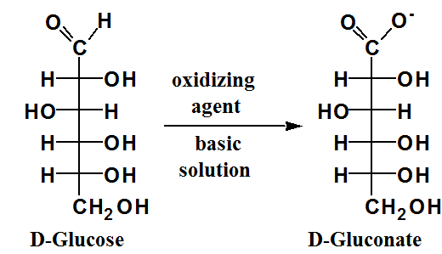

**Enzyme oxidation**

In biochemical systems enzymes can oxidize the primary alcohol end of an aldose such as glucose, without oxidation of the aldehyde group, to produce an ***alduronic acid****.*

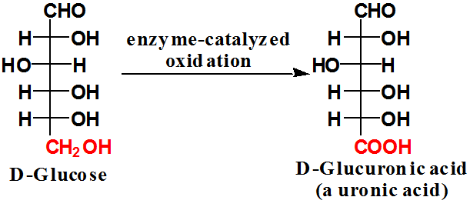

**b) Reduction to sugar alcohols**: The carbonyl group in amonosaccharide (either an aldose or a ketose) is reduced to a hydroxyl group using hydrogen as the reducing agent.

The product is the corresponding polyhydroxy alcohol - **sugar alcohol**.

**Sorbitol** - used as moisturizing agents in foods and cosmetics and as a sweetening agent in chewing gum

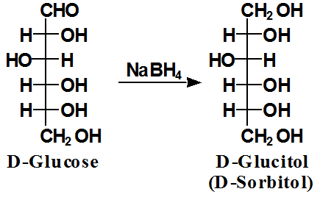

**c) Glycoside formation**

**Simple carbohydrates: Monosaccharide** and **Disaccharide** ofsimple sugars such as glucose or fructose. **Disaccharide** are two monsaccharides connected by a bridging O atom called a glycosidic bond  as in sucrose.   
**Glycosidic bond**- covalent bond between a hemiacetal or hemiketal and an alcohol.   
Glycoside- compound formed when a sugar in the cyclic form is bonded to an alcohol through a glycosidic bond to another sugar molecule as shown below.

****

**Phosphate ester formation**

The hydroxyl groups of a monosaccharide can react with inorganic oxyacids to form inorganic esters as described in the Section 16.20 (chapter 16). Phosphate esters, formed from phosphoric acid and various monosaccharides, are commonly encountered in biochemical systems. For example specific enzymes in the human body catalyze the esterification of the hemiacetal group (carbon 1) and the primary alcohol group (carbon 6) in glucose to produce the compound **glucose** **1-phosphate** and glucose 6-phosphate, respectively.

**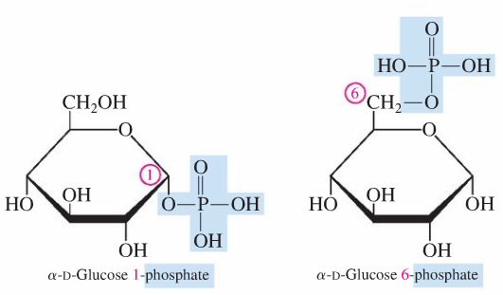** 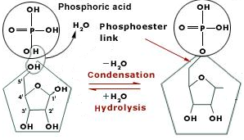

Similarly, esterification the primary alcohol group (carbon 5) in ribose combine to produce the compound **ribose** **5-phosphate** and glucose 6.

**Amino Sugar Formation**

If one of the hydroxyl groups of a monosaccharide is replaced with an amino group, a amino sugar is produced. In naturally occurring amino sugars, of which there are there common ones, the amino group replaces the carbon 2 hydroxyl group. The three comma natural amino sugars are:**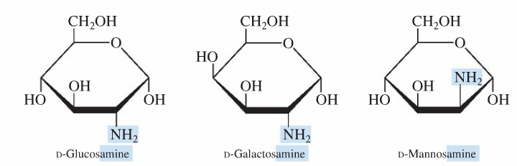**

**18.13 Disaccharides**

A disaccharide forms by reaction of the -OH group on the **anomeric carbon** of one monosaccharide with an –OH group of a second monosaccharide.

The linkage between monosaccharides in a disaccharide is referred to as a **glycosidic linkage** and is named according to the number of the carbon at which the linkage begins and the carbon on the second monosaccharide at which the linkage ends.

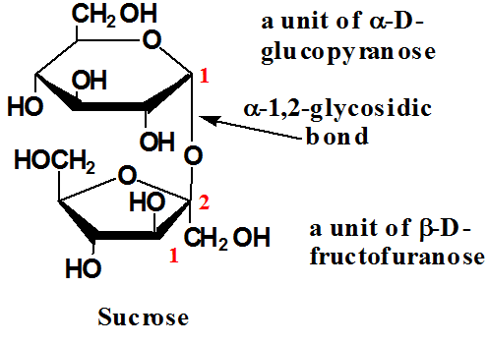-The glycosidic linkage is also designated a or β, depending upon whether the conformation at the anomeric carbon is up or down.

**Sucrose**

glucose + fructose --- glucose  , (1---2) fructose  sucrose, a non reducing sugar

Consider the three disaccharide structures maltose, lactose and sucrose  and explain why sucrose is NOT a reducing sugar.

**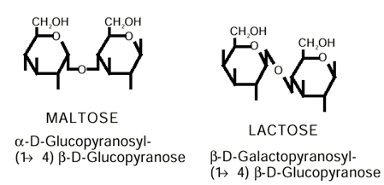**

**Disaccharides** with (1---4),  (1---4) and  (1---2)  glycosidic bonds that yield disaccharide,  maltose, lactose and sucrose, respectively. Both  (1---4) and (1---4)  glycosidic bonds leave one hemiacetal or hemiketal free and these ends will show a postive behavior for the Benedict's test. E.g **maltose and lactose**. Fructose having  (1---2)  glycosidic bondhave protected acetal and ketal groups which are unable to undergo enediol conversion or reaction with Benedict's reagent. Therefore **fructose** is considered as a **non reducing sugar**.

**Maltose**   
glucose + glucose --- glu  (1---4) glu          maltose, a reducing sugar   
  
  **Lactose**   
galactose + glucose --- gal  (1---4) glu        lactose,  a reducing sugar   
  
**18.14 General Characteristics of Polysaccharides**

* Storage polysaccharides
* Energy storage - starch and glycogen
* Structural polysaccharides
* Used to provide protective walls or lubricative coating to cells - cellulose and mucopolysaccharides.
* Structural peptidoglycans
* Bacterial cell walls

**18.15 Storage Polysaccharides**

**Amylose**

**Amylopectin**

|  |  |
| --- | --- |
| **Plant Starch** | |
| **amylose**  (1---4) glucose   linear molecule   coils up   less water soluble   non reducing sugar | **amylopectin**  (1---4) and  (1---6) glucose   branched molecule   open spiral molecule   more water soluble   non reducing sugar |

**Glycogen**

|  |
| --- |
| **Animal Starch**  **glycogen**   (1---4) and  (1---6) glucose   branched molecule   open spiral molecule   more water soluble   non reducing sugar |

 **Cellulose**

|  |  |
| --- | --- |
| **Structural Polysaccharides:** | |
| **Cellulose**   (1---4) glucose   ribbon molecule   ribbons stack   water insoluble   non reducing sugar | | **Chitin**  (1---4) N-acetylglucosamine   ribbons stack   water insoluble   non reducing sugar chitin    See bacterial cell wall, text book page 160, for structure of  N-acetylglucosamine |

**18.16 Structural Polysaccharides**

**Mucopolysaccharides**   
**AMINOSUGAR** or N-acetyl-D-glucosamine: glucose-derivative with an acetylated amino group on C-2 as found in N-acetylglucosamine.

**Deoxysugar or  D-deoxyribose:  ribose-derivative with an oxygen missing on C-2.**

**18.17 Acidic Polysaccharides**

An acidic polysaccharide is a polysaccharide with a disaccharide repeating unit which one of the disaccharide components is an amino sugar and one or both disaccharide components has a negative charge due to a sulfate group or a carboxyl group. Unlike tl polysaccharides discussed in the previous two sections, acidic polysaccharides are heter polysaccharides; two different monosaccharides are present in an alternating patter Acidic polysaccharides are involved in a variety of cellular functions and tissues. Two of the most well-known acidic polysaccharides are **hyaluronic acid** and heparin both of which have unbranched-chain structures.

**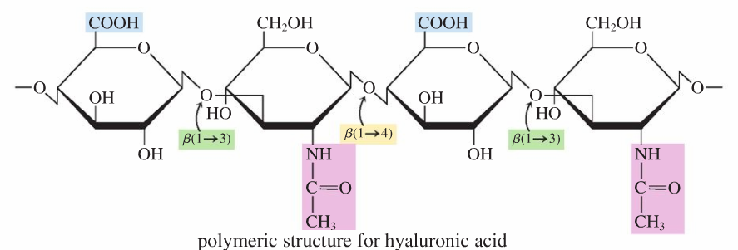**

**18.18 Glycolipids and Glycoproteins: Cell Recognition**

The biochemistry of carbohydrates was thought to be rather simple. These compounds served 1) as energy sources for plants, humans, and animals and 2) as structural materials for plants and arthropods.

Curent Research has shown that oligosaccharides (Section 18.2) can get attached through glycosidic linkages to lipid molecules (Chapter 19) or to protein molecules (Chapter 20) have a wide variety of cellular functions including the process of cell recognition. Such molecules, called **glycolipids** and glycoproteins, respectively, often govern how individual cells of differing function within a biochemical system recognize each other and how cells interact with invading bacteria and viruses. A glycolipid is a lipid molecule that has one or more carbohydrate (or carbohydrate derivative) units covalently bonded to it. Similarly, a glycoprotein is a protein molecule that has one or more carbohydrate (or carbohydrate derivative) units covalently bonded to it.

The lipid or protein part of the glycolipid or glycoprotein is incorporated into the cell membrane structure and the carbohydrate (oligosaccharide) part functions as a marker on the outer cell membrane surface. Cell recognition generally involves the interaction

**18.19 Dietary Considerations and Carbohydrates**

**The glycemic index (Gl)**: It is a dietary carbohydrate rating system that indicates how fast a particular carbohydrate is broken down into glucose (through hydrolysis) and the level of blood glucose that results. Its focal point is thus blood glucose levels.

Slow generation of glucose, a modest rise in blood glucose, and a smooth return to normal blood glucose levels are desirable. A rapid increase (surge) in blood glucose levels, with a resulting overcorrection (from excess insulin production) that drops glucose levels below normal, is undesirable. Low-GI foods promote the first of these two effects, and high-GI foods promote the latter. Selected examples of Gl ratings for foods are given in the accompanying tables.

Considerations relative to use of Gl values such as these include the following:

1. At least one low-GI food should be part of each meal. 2. Fruits, vegetables, and legumes tend to have low-GI ratings.

3. Whole-grain foods, substances high in fiber, tend to have slower digestion rates.

4. High-GI rated foods should still be consumed, but as part of

meals that also contain low-GI foods.

**Galactosemia and Lactose Intolerance**

**The difference between galactosemia and lactose intolerance.   
Galactosemia**   
Milk products which contain lactose are conversted to galctose and glucose in the digestive track. Both glucose and galactose are absorbed by the body and used to produce energy. However, galactose has to be converted phosphorylated glucose before it can be used by the body. Galactosemia is a genetic desease caused by a lack of  enzymes necessary for the conversion of galactose to phosphorylated glucose which is used in the cellular metabolism or glycolysis. A toxic compound formed from galactose accumulates in people with galactosemia. Treatment for galactosemia is the use of non dairy products which does not contain lactose.

**Lactose intolerance**

Milk products which contain lactose are conversted to galctose and glucose in the digestive track using an enzyme called lactase. People with lactose intolerance does not produce or produce very little or no lactase and the undiagested lactose in the intestinal tract are metabolised by bacteria releasing CO2 and other organic acids causing cramping and diarreha. People with this condition can take supplements with lactase along with their food and enjoy eating dairy products or use a diet devoid of lactose coming from milk products.

Lactose intolerance is present in 75 percent of adults the world over. Its clinical manifestations include abdominal pain, bloating, gas and diarrhea upon consumption of dairy products. An intestinal enzyme called lactase splits lactose into two glucose molecules, enabling them to pass through the  intestinal walls and into the bloodstream. Lactase deficiency leads to an inability to digest lactose, which becomes   fermented by bacteria, producing hydrogen and other gases. Lactose also attracts water molecules into the colonic lumen,  causing loose stools or diarrhea. What is the difference between lactose intolerance and milk allergy? Intolerance to   lactose is hardly immunological in origin and occurs during late childhood or adolescence. Milk allergy, on the other hand,  is an allergic reaction manifested by diarrhea, vomiting, abdominal pain, asthma, hives and sometimes, anaphylaxis.   Allergy occurs during the first four months of life and ceases by the baby's first birthday. The simplest way to treat lactose   intolerance is by avoidance of dairy products. Tests used to diagnose the problem are lactose intolerance test, hydrogen  breath test and stool acidity test. To minimize symptoms of lactose intolerance, space the consumption of milk throughout  the day. Lactose- containing foods should be eaten together with other foods. Enzyme supplements are also helpful in converting lactose consumed to glucose and galactose.