**Chapter 16: Carboxylic Acids, Esters, and Other Acid Derivatives**

In Chapter 15, we discussed the carbonyl group and two families of compounds -aldehydes and ketones—that contain C=O group. In this chapter, we discuss six more families of compounds in which the carbonyl group is present: a) carboxylic acid, b) esters, c) amides, d) acid chlorides, and e) acid anhydrides and f) carboxylic acid salts.

**16.1 Structure of Carboxylic Acids and Their Derivatives**

A carboxylic acid is an organic compound whose functional group is the carboxyl group. What is a carboxyl group? A carboxyl group is a carbonyl group (C=O) with a hydroxyl group (—OH) bonded to the carboxyl carbon atom. A general structural representation fit a carboxyl group is

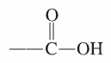

Abbreviated linear designations for the carboxyl group are



Although we see within a carboxyl group both a carbonyl group (C=O) and hydroxyl group (—OH).

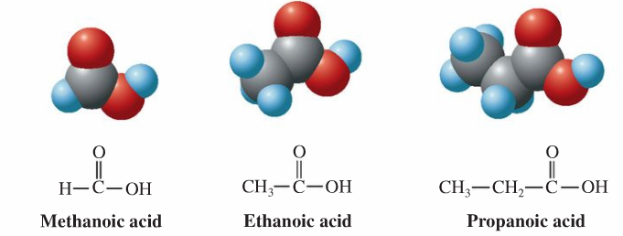

**16.2 IUPAC Nomenclature for Carboxylic Acids**

The naming of carboxylic acids is fairly simple. You simply find the longest carbon chain which includes the carboxylic group. Use that as the stem for the name, cross off the **-e** on the ending of the alkane name and replace it with **-oic acid**.

|  |  |  |  |
| --- | --- | --- | --- |
| I think you can see how that works, if you look at this example (which is also shown in Example 1-a in your workbook). It gives you, in this case (with a three-carbon-atom chain), the name **propanoic acid**. | |  | | --- | |  | | **propanoic acid** (from **propan** + **oic acid**) | |

As with aldehydes, it is **not necessary to indicate where** the acid functional group is because it has to be at the end of the molecule, on the #1 carbon. There is no way that this functional group can be anywhere else. Therefore, if there is any numbering to be done, it will be to show where additional alkyl groups or other groups are attached to the carbon chain. The numbering starts from the carboxylic group.

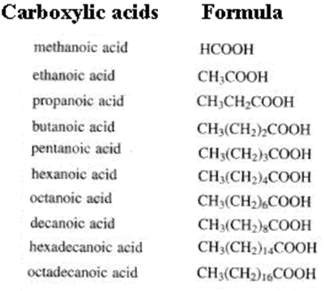

**16.3 Common Names for Carboxylic Acids**

Carboxylic acids are another example of a situation where the compounds were known and named long before anyone thought of the IUPAC method of naming compounds. Consequently, many carboxylic acids have their own common name which is distinct from the IUPAC name. The two most important of these (and the only two you will be held responsible for in this course) are shown below. They are **formic acid** and **acetic acid**. (These are also shown in Examples 1b and c in your workbook.)

|  |  |  |  |
| --- | --- | --- | --- |
| Here is the structural formula for **formic acid**. Its IUPAC name is methanoic acid, using the **meth-** stem because it has **one** carbon atom. | |  | | --- | |  | | **formic acid**  methanoic acid | |
| **Acetic acid** has two carbon atoms. Therefore it can also be called ethanoic acid. | |  | | --- | |  | | **acetic acid**  ethanoic acid | |

**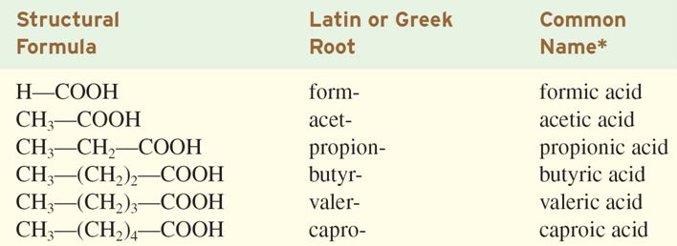**

**Naming using Greek letters           **  
There are two ways to identify substituent carbons in carboxylic acid: numbers or Greek letters.   
Using numbers, the carboxyl group carbon is given the number one.   
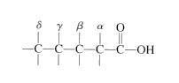   6 5 4 3 2 1    
                             C-C-C-C-C-COOH    
                                                                     

When Greek letters are used, Greek letters are used to designate the position of substituent relative to the carbon of the carboxyl group.  The carbon of the carboxyl group is **NOT** given a Greek letter.   
6) A special group of carboxylic acids are those that also have a keto group.  They are called alpha-keto carboxylic acids

**16.4 Polyfunctional Carboxylic Acids**

Dicarboxylic acids are organic compounds that are substituted with two carboxylic acid functional groups. They are important metabolic products of fatty acids when they undergo oxidation.

|  |  |  |  |
| --- | --- | --- | --- |
| **Common Name** | **IUPAC Name** | **Condensed Formula** | **Structural Fromula** |
| **Oxalic acid** | **ethanedioic acid** | HOOC-COOH | **Oxalic acid.png** |
| **Malonic acid** | **propanedioic acid** | HOOC-(CH2)-COOH | **Malonic acid structure.png** |
| **Succinic acid** | **butanedioic acid** | HOOC-(CH2)2-COOH | **Succinic acid.png** |
| **Glutaric acid** | **pentanedioic acid** | HOOC-(CH2)3-COOH | **Glutaric acid.png** |
| **Adipic acid** | **hexanedioic acid** | HOOC-(CH2)4-COOH | **[Adipic acid structure.png](http://en.wikipedia.org/wiki/File:Adipic_acid_structure.png)** |
| **Pimelic acid** | **heptanedioic acid** | HOOC-(CH2)5-COOH | **Pimelic acid.png** |

**16.5 "Metabolic" Acids**

Metabolism is the set of chemical reactions that occur in a cell, which enable it to keep living, growing and dividing. There many acids involved in metabolic processes and a basic understanding of their structures and properties are necessary to understand the biochemistry.

Metabolic acids are polyfunctional acids formed as intermediates of metabolic reactions in the human body. There are eight such acids that will appear repeatedly in the biochemical pathways.

Metabolic acids are derived from:

**Propionic acid, (C3 mono acids):**

lactic, glyceric, and

pyruvic acids

**Succinic acid (C4 diacid):** fumaric, oxaloacetic, and malic acids

**Glutaric acid (C5 diacid):** -ketoglutaric and citric acids

**16.6 Physical Properties of Carboxylic Acids**

Carboxyl groups exhibit very strong hydrogen bonding. A given carboxylic acid molecule form two hydrogen bonds to another carboxylic acid molecule, producing a “dimer”, a complex with a mass twice that of a single molecule.

Compounds with carboxyl groups have higher boiling points than alcohols.  This is because the carboxyl groups hydrogen bond more strongly than alcohols.

|  |  |
| --- | --- |
| figure_16_10 |  |

Carboxyl groups make molecules very soluble in water because the group can strongly hydrogen bond with water.

****

**Physical Properties of carboxylic acids derivatives**   
     Depending upon the substituent replacing -OH of the caboxylic functional group the physical properties could change.   
However, they have lower boiling and melting points than parent acid.

**16.7 Preparation of Carboxylic Acids**

Carboxylic acids are easily by oxidation of primary alcohols and aldehydes.  When the oxidation process begins with an alcohol it is difficult to stop at the aldehyde stage of oxidation.

**Oxidation of primary alcohol to carboxylic acid.**   
**Chemical equations**

                       CH3CH2CH2OH  --->   CH3CH2CHO  --->  CH3CH2COOH   
                              primary alcohol            aldehyde            acid

                         Ar-CH2-OH   --->   ArCHO   --->   Ar-COOH

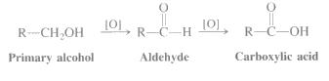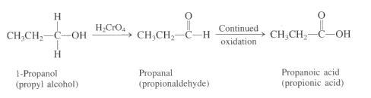

**Oxidation using  basic Ag(NH3)2+**

A basic Ag(NH3)2+ in aqueous ammonia reduces  to metallic silver (mirror) with aldehyde oxidized to carboxylic acid.

http://www.chem.latech.edu/~upali/chem121-old/imageG1A.JPG

The commercial manufacture of silver mirrors uses a similar process.

**Oxidation of alkyl side chain substituted on a benzene ring to an acid functional group.**

                Ar- CH2 -CH3  --->   Ar- COOH   
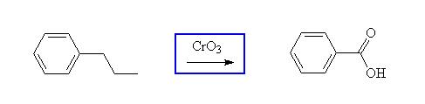  
**hydrolysis of esters.**   
  acid-catalyzed hydrolysis is the exact reverse of Fisher esterification (same mechanism)   
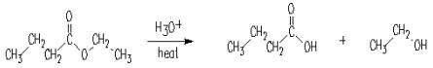

**Reactions of Carboxylic Acid**

**Reaction with strong bases to form acid salts** (described below in preparation of acid salts)

**Reaction with strong alcohols to form esters** (described below in preparation of esters-esterification)

**Reaction with halogen compounds to form acid chlorides**(described below in preparation of acid chloride preparations)

**Reaction with ammonia and amine compounds to form amides** (described below in preparation of amides chapter 18)

[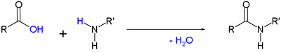](http://en.wikipedia.org/wiki/File:SimpleAmideFormationByCondensation.png)

**Reactions of -keto acids.**   
-keto acids are readily decarboxylated.

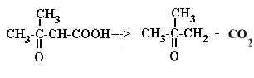

**16.8 Acidity of Carboxylic Acids**

Carboxylic acids are weak acids.

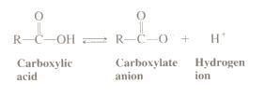

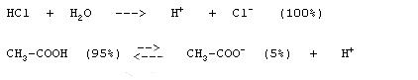

**Acid base reactions**:

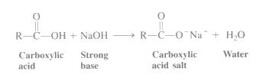

**16.9 Carboxylic Acid Salts**

Naming carboxylic acid follows certain pattern for example the structural formula for the compound. Since this sodium salt of propanoic acid - so start from propanoic acid is a three carbon acid with no carbon-carbon double bonds and this negative ion without the H+ atom is called propanoate. There this salt is named: **sodium propanoate**

When the carboxylic acids form salts, the hydrogen in the -COOH group is replaced by a metal. Sodium alkan**oate (propan-oate)** is therefore:

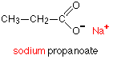

**Preparation of acid salts**   
Acid salts are prepared by the reaction of acid with a base such as sodium hydroxide.   


**16.11 Preparation of Esters**

**Naming Esters**:

1. Identify the alkyl group that is attached to the oxygen atom
2. Number according to the end closest to the -CO- group regardless of where alkyl substituents are.
3. Determine the alkane that links the carbon atoms together. If there is a separation of a continuous link of carbon atoms due to the oxygen atom, individually name the two alkanes before and after the oxygen atom. The longer structural alkane is the one that should contain the carbonyl atom.
4. The format is as follows: (alkane further from carbonyl) (alkane closest to carbony)(parent chain)
5. Change the parent chain -e ending and replace it with an -oate.

Example:

CH3COOC7H14CH3

**octyl ethanoate**

**Common Esters**

**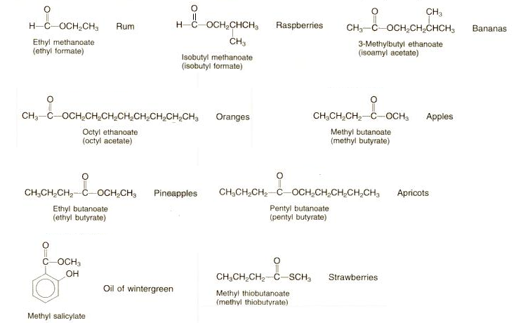**

**Esterification form acid and alcohol**   
        acid         +       alcohol   ---->     ester          +     H2O   
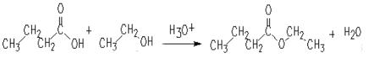  
**Esterification from acid chlorides and alcohol**   
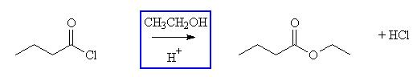  
Note: the acid loses an -OH units and the alcohol loses a -H in this reaction.

**16.14 Isomerism for Carboxylic Acids and Esters**

**16.16 Chemical Reactions of Esters**

**Hydrolysis**   
1) **acid-catalyzed hydrolysis** is the exact reverse of Fisher esterification (same mechanism)   
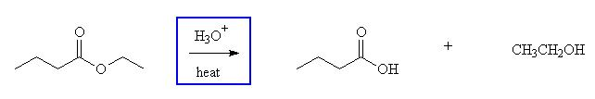2) **base-catalyzed hydrolysis** is often called **saponification** (soap-making)  saponification is irreversible because a carboxylate salt is formed.

**Saponification of triglycerides and action of soap in the emulsification of grease and oils.**   
Soap has been around for hundreds of years.  In it's simplest form, soap is made by heating fat  in boiling water that also has   
sodium hydroxide (NaOH)or potsssium hydroxide (KOH) ions in it.  Each  fat molecue breaks down into three molecules of   
fatty acids.  The molecules of fatty acids then react with the sodium or potassium ions to form soap molecules and glycerin.

**triglyceride**

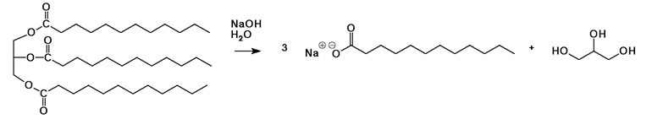             **glycerol**   
If the triglyceride had three different fatty acids following products with three fatty acids are formed.

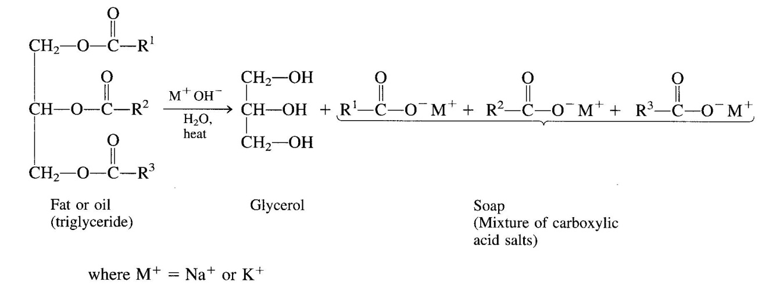  
Soaps are water-soluble sodium or potassium salts of long-chain (fatty) acids ( C8-C20 ). Fats are the esters of fatty acids and glycerol (1,2,3-propanetriol ). Base-catalyzed hydrolysis is often called saponification (soap-making)  saponification is irreversible because a carboxylate salt is formed.   
**How does soap work?**   
In the cleaning process, surface tension must be reduced so water can spread and  wet surfaces. Chemicals that are able to do this effectively are called surface active agents, or surfactants. They are said to make water "wetter."  Soap perform other important functions in cleaning,  such as loosening, emulsifying (dispersing in water) and  holding soil in suspension until it can be rinsed away. Soap can also provide alkalinity, which is useful in removing acidic soils.

**16.18 Polyesters**

Polyesters are formed by condensation polymers are any kind of polymers formed through a condensation reaction, releasing small molecules as by-products such as water or methanol, as opposed to addition polymers which involve the reaction of unsaturated monomers. Types of condensation polymers also include polyamides, polyacetals.

**Condensation polymerization**   
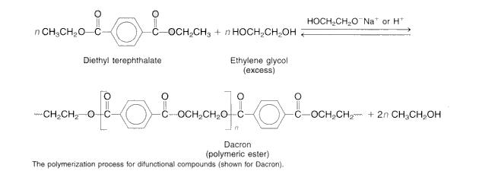

**16.19 Acid Chlorides and Acid Anhydrides**

**Preparation of acid anhydrides**

Acid chlorides are prepared by the rection of acid  with PCl3, PCl5 or SOCl2..   
Acid anhydrides are prepared by the rection of acid chlorides with its sodium salt.   
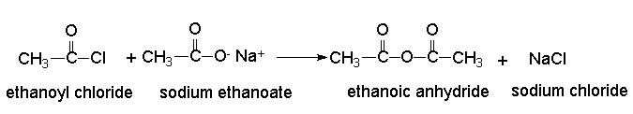  
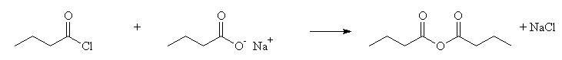  
    **Butanoyl chloride    sodium butanoate                             butanoic anhydride**

**16.20 Esters and Anhydrides of Inorganic Acids**

Adenosine triphosphate (ATP) consists of the nitrogenous base adenine   bonded to the sugar ribose, which is connected to a chain of 3  phosphate groups.   
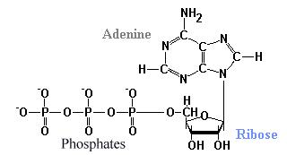  
**ATP hydrolysis releases energy**

Phosphate groups are negatively charged, and repel in ATP.    Release of phosphate gives a large positive entropy change.  We synthesize an amount of ATP equal to our body weight every day.    
The first step in glycolysis is the formation of glucose-6 phosphate from glucose. The direct reaction of inorganic phosphate (Pi) with glucose is unfavorable.  However, the hydrolysis of ATP is extremely favorable. In a cell the enzyme hexokinase  catalyzes the coupled reaction of ATP with glucose favoring the formation of glucose-6-phosphate.

**Thioesters** : **Acetyl CoA**

Thioesters are more susceptible toward nucleophilic attack than are  esters and acids. Thioesters are intermediate in reactivity between acid chlorides and esters making them perfect functional groups for biological systems.

