**Chapter 14: Alcohols, Phenols, and Ethers**

This chapter is the first of three that consider hydrocarbon derivatives with oxygen. This chapter is the first of three that consider hydrocarbon derivatives with o containing functional groups. Many biochemically important molecules contain carbon atoms bonded to oxygen atoms.

In this chapter we consider hydrocarbon derivatives whose functional groups contain one oxygen atom participating in two single bonds (alcohols, phenols, and ethers). Chapter 15 focuses on derivatives whose functional groups have one oxygen atom participating in a double bond (aldehydes and ketones), and in Chapter 16 we examine functional groups that contain two oxygen atoms, one participating in single bonds and the other in a double bond (carboxylic acids, esters, and other acid derivatives).

**14.1 Bonding Characteristics of Oxygen and Sulfur Atoms in Organic Compounds**

Oxygen and Sulfur are Group VIA Elements Has 6 valance electrons

* Two lone pairs
* Two bonding pairs, i.e., it can form two covalent bonds
* Two single or one double bond

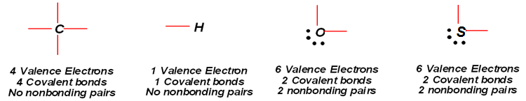

**14.2 Structural Characteristics of Alcohols**

**-OH unctional groups:**

Alcohol: **R-O-H**

Phenols: **Ar-OH**

**Alcohol:** An organic compound in which an —OH group is bonded to a saturated carbon atom.

Saturated carbon atom: A carbon atom that is bonded to four other atoms.

General structure: R-OH (OH is functional group)

* + Examples: CH3OH, C3H7OH
  + OH in alcohols is not ionic as in NaOH.

**14.3 Nomenclature for Alcohols**

**Common names** : Alcohols (C1-C4 alkyl groups).

* **Rule 1**: Name all of the carbon atoms of the molecule as a single alkyl group.
  + Example: Methyl (C1), Ethyl (C2), propyl (C3) butyl (C4)
* **Rule 2**: Add the word alcohol, separating the worlds with a space.
* Examples



**The IUPAC Names:**

The **IUPAC system** deals with functional groups two different ways.

Modification of the hydrocarbon name to indicate the presence of a functional group.

• OH group takes priority (even over -ene or -yne)

- it must be in the parent chain

- the direction of numbering gives it the lowest possible number to carbon with –OH.

• -ol suffix with number designation

• name other substituents and multiple bonds as usual

alcohol, -OH use **-ol** ending.

ether: CH3CH2-O-CH3 use **methoxy** **methoxy ethane**

**Examples:**



*Common names are in parenthesis



**Octanol**

**4-methyl-2-pentanol**

**2-isopropyl cyclohexanol**

**IUPAC naming of unsaturated alcohols**

* the double bond is shown by the infix -en-
* the hydroxyl group is shown by the suffix -ol
* number the chain to give OH the lower number



**Alcohol with More than one –OH group**

Polyhydroxy alcohols—alcohols that possess more than one hydroxyl group—can b named with only a slight modification of the preceding IUPAC rules. An alcohol in which two hydroxyl groups are present is named as a diol, one containing three hydroxyl group is named as a triol, and so on. In these names for diols, trials, and so forth, the final -e c the parent allkane name is retained for pronunciation reasons.

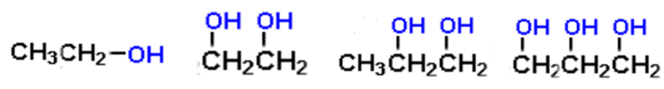

**1-Ethanol 1,2-Ethanediol 1,2-Propanediol 1,2,3-Propanetriol**

**(ethyl alcohol) (ethylene glycol) (propylene glycol) (glycerol )**

The first two of the preceding compounds have the common names ethylene glycol and propylene glycol. These two alcohols are synthesized, respectively, from the alkene ethylene and propylene (Section 13.3), hence the common names.

**14.4 Isomerism for Alcohols** (Constitutional Isomerism)

**Isomerism in butanol**

Constitutional isomerism is possible for alcohols containing three or more carbon atoms.

Two types of isomers

Skeletal isomers

Positional isomers

At with alkenes (Section 13.5), both skeletal isomers and **positional isomers** are possible. For monohydroxy saturated alcohols, there are two C3 isomers, four C4, and eight for C5 isomers.

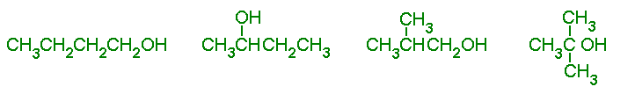

**1-butanol 2-butanol 3-methyl-1-propanol 2-methyl-2-propanol**

**C5 isomers**

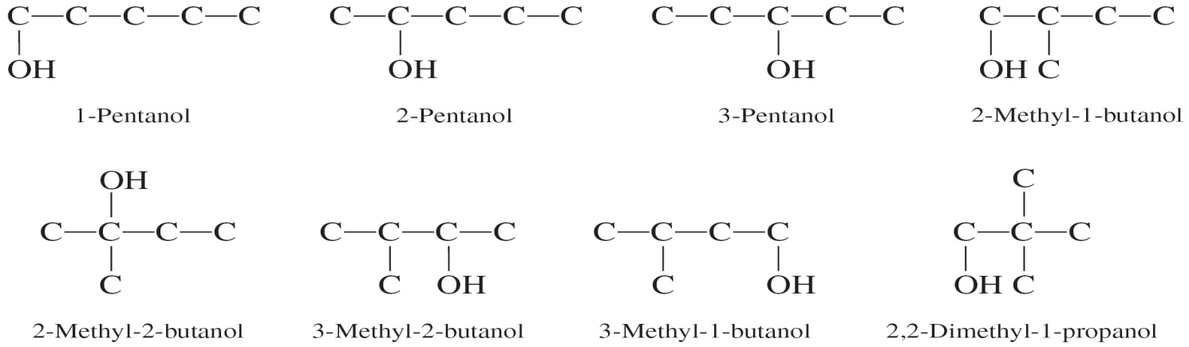

**14.5 Important Commoly Encountered Alcohols**

**Methyl Alcohol (Methanol)**

* Good fuel and used as a solvent in paints
* Commonly called wood alcohol – original method of its preparation was by heating wood at high temperature in the absence of air.
* Currently, nearly all methyl alcohol is produced via the reaction between H2 and CO.
* Toxic: oxidized by alcohol dehydrogenase in the body to toxic formaldehyde and formic acid – toxic to the eye and can cause blindness and/or optic nerve damage.
  + Treated with ethanol: Ethanol stops oxidation of methanol by competing with alcohol dehydrogenase enzyme.

**Ethyl Alcohol (Ethanol)**

* Also called grain alcohol as obtained by fermentation of grains like corn, rice and barley.
* Prepared by yeast fermentation of plant sugars by yeast
  + Maximum concentration of ethanol: 18% (yeast enzymes are inactivated at higher concentration of alcohol)
  + Excellent solvent and a fuel
  + Distributed as denatured Alcohol: Toxic substances such as methanol are added to prevent human consumption
  + Oxidized by body to acetaldehyde – toxic and causes hangover effects of alcohol
  + Consumption of alcohol during pregnancy can cause birth defects and fetal alcohol syndrome
  + Also know to cause liver damage, loss of memory and alcoholism (addiction to alcohol)

**Isopropyl Alcohol (2-Propanol)**

* + Isopropyl alcohol is a three-carbon monohydroxy alcohol.
  + A 70% isopropyl alcohol in water is marketed as rubbing alcohol (used to combat high body temperature by rubbing on the skin).
  + Isopropyl alcohol has a bitter taste.
  + Toxicity: Twice that of ethyl alcohol (often induces vomiting and thus doesn’t stay down long enough to be fatal).
  + In the body it is oxidized to acetone.

**Glycerol (1,2,3-Propanetriol)**

* + Glycerol is a **triol** with three -OH groups attached on three adjacent carbon atoms.
  + Clear thick liquid
  + Byproduct of fat metabolism
  + Used in skin lotions and soaps
  + Used in shaving creams due to lubricating properties
  + Often called biological antifreeze

**14.6 Physical Properties of Alcohols**

Alcohol molecules have both **pola**r and **nonpolar** character.

* + The hydroxyl group is polar part of the molecule
  + The alkyl (R) group is nonpolar part of the molcule

The physical properties depend on which portion of the structure “dominates.”

* Length of the nonpolar carbon chain
* Number of polar hydroxyl groups

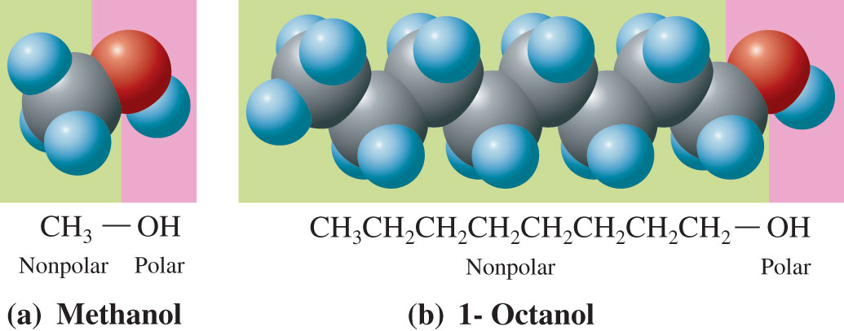

Space-filling molecular models showing the nonpolar (green) and polar (pink) parts of methanol and 1-octanol.

The polar **hydroxyl functional group** dominates the physical properties of methanol. The molecule is completely soluble in water (polar) but only partially so in hexane (nonpolar).

Conversely, the nonpolar portion of 1-octanol dominates its physical properties; it is infinitely soluble in hexane and has limited solubility in water.

**Boiling Points and Water Solubilities**

* The boiling points of 1-alcohols with an —OH group on an end carbon increases as the length of the carbon chain increases.
* Small monohydroxy alcohols are soluble in water in all proportions.
* As carbon chain length increases beyond three carbons, solubility in water rapidly decreases

**Boiling Points and Solubilities in Water (of selected 1-alcohols)**

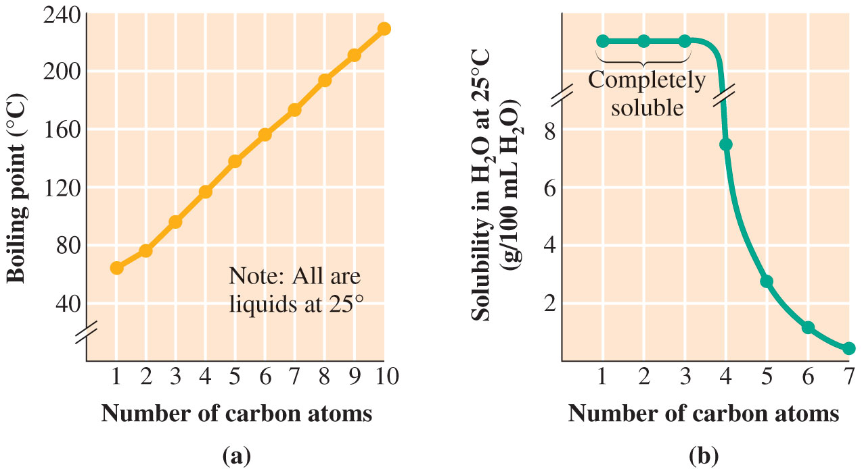



**Alcohols and Hydrogen Bonding**

The differences in physical properties between alcohols and alkanes

* 1. Alcohols have higher boiling points than alkanes of similar molecular mass.
  2. 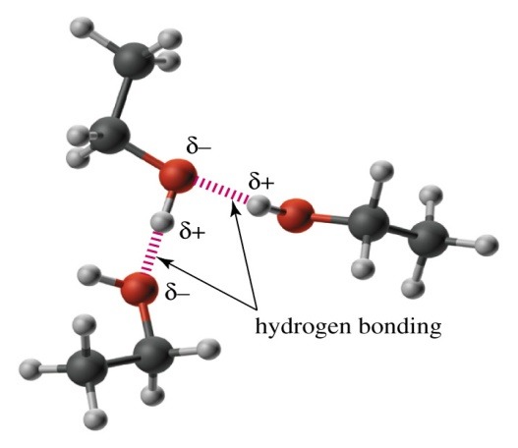Alcohols have much higher solubility in water than alkanes of similar molecular mass.

**Figure** shows the association of ethanol molecules in the liquid state (only two of the three possible hydrogen bonds to the upper oxygen are shown here).

Alcohols have higher boiling points and are more soluble in water than hydrocarbons

**14.7 Preparation of Alcohols**

**14.8 Classification of Alcohols**

Alcohols are classified as **primary (1o), secondary (2o),** or **tertiary (3o)** alcohols

**Primary alcohol (1o):** Hydroxyl-bearing carbon atom is bonded to only one other carbon atom.

**Secondary alcohol (2o):** Hydroxyl bearing carbon atom is bonded to two other carbon atoms.

**Tertiary alcohol (3o):** Hydroxyl-bearing carbon atom is bonded to three other carbon atoms.

Reactions are dependent on the type of alcohol **1o, 2o,** or **3o**

|  |  |  |
| --- | --- | --- |
| **Primary** | **Secondary** | **Tertiary** |
|  |  |  |

**14.9 Chemical Reactions of Alcohols**

**Combustion Reactions**

Like other hydrocarbons alcohols are also flammable.

The combustion products are carbon dioxide and water.

2 CH3OH + 4O2 🡪 2CO2 + 4 H2O

**Alcohol Dehydration**

**Intramolecular- Alcohol Dehydration**

* A dehydration reaction in which the components of water (-H and -OH) are removed from a single reactant
* An alcohol can be converted to an alkene by elimination of H and OH from adjacent carbons (a -elimination)



**Intermolecular- Alcohol Dehydration**

In this reaction, two molecules of alcohol combine to form an ether (Condensation reaction)

* Only true for **primary alcohols** and 140oC.



* **Secondary** and **tertiary** alcohols always give alkene.

Dehydration of an alcohol can result in more than one alkene product, because hydrogen loss can occur from either of the neighboring carbon atoms.

Example: Dehydration of 2-butanol produces two alkenes.

Zaitsev’s rule (or the opposite of **Markovnikov’s rule**) can be used determine the dominant product.

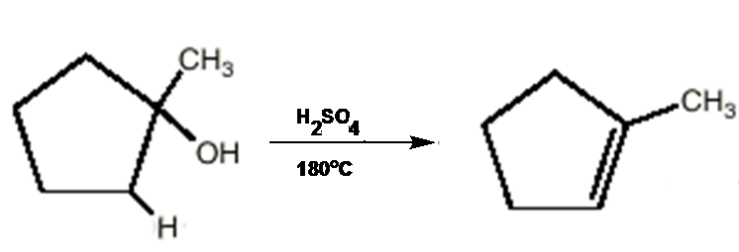

**Oxidation of Alcohols**

Addition of oxygen or removal of hydrogen

Mild Oxidizing Agents: KMnO4, K2Cr2O7, H2CrO4

Primary and Secondary Alcohols can be oxidized by mild oxidizing agents

**1° alcohol**

Oxidation of a **1° alcohol** gives an **aldehyde** and then get oxidized to **carboxylic acid**, depending on the oxidizing agent and experimental conditions

* + the most common oxidizing agent is chromic acid



* + chromic acid oxidation of 1-octanol gives octanoic acid****

**2° alcohol**

Oxidation of a **2° alcohol** gives an **Ketone** the most common oxidizing agent is chromic acid.

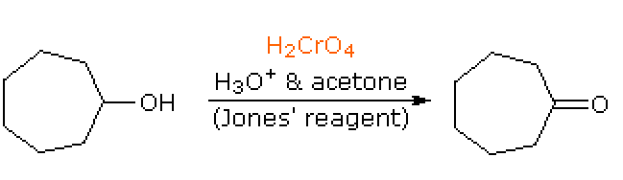

chromic acid oxidation of heptanol gives heptanone.

**2° alcohol**

Oxidation of a **2° alcohol** gives an **Ketone** the most common oxidizing agent is chromic acid.

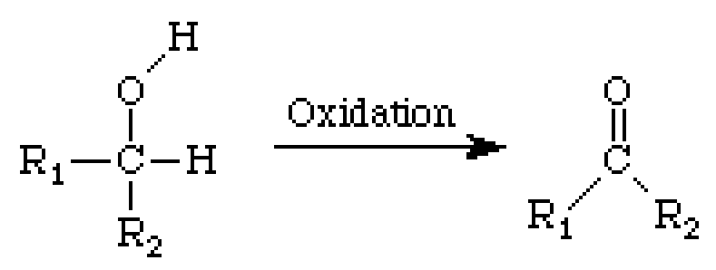

Chromic acid oxidation of heptanol gives heptanone.



**3° alcohol**

Oxidation of a **3° alcohol** will not take place there is no hydrogen to be removed from a 3° carbon atom on a 3° alcohol.



**Reactivity of 1o, 2o and 3o alcohols: Oxidation**



**Halogenation of Alcohol**

Alcohols undergo halogenation reactions. In this reaction a halogen atom is substituted for the hydroxyl group producing an alkyl halide.

Alkyl halide production by this reaction is superior to alkyl halide production through halogenation of an alkane.





(PX3: X is Cl or Br)



**Polymeric Alcohols**

**Polyvinyl alcohol (PVA)**

It is possible to synthesize polymeric alcohols with structures similar to those of substituted polyethylenes.

The simplest polymer is polyvinyl alcohol (PVA)

* + PVA is a tough, whitish polymer that can from strong films,
  + tubes, and fibers that are highly resistant to hydrocarbon solvents
  + Unlike most organic polymers, PVA is water-soluble

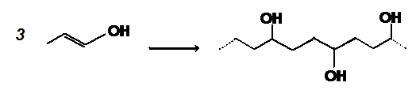

**14.11 Structural Characteristics of Phenols**

**Phenol:** An organic compound in which an —OH group is attached to a carbon atom that is part of an aromatic carbon ring system

Aryl group: An aromatic carbon ring system from which one hydrogen atom has been removed.

General formula for an aryl alcohol: Ar-OH

Substituted phenols: Aryl group substituted with other groups like CH3, NO2 , etc.



**Substituted phenol**

**Phenyl, Ar = C6H5**

**4-chloro-3-methyl phenol**

**14.12 Nomenclature for Phenols**



**m-bromophenol o-methylphenol**





**14.13 Physical and Chemical Properties of Phenols**

**Phenols** :

* Low-melting solids or oily liquids at room temperature.
* Sparingly soluble in water
* Many phenols have antiseptic and disinfectant properties.
* The simplest phenol: phenol
* A colorless solid with a medicinal odor
* Melting point: 41oC
* More soluble in water than any other phenols

**Acidity of Phenols**

* Unlike alcohols, phenols are weak acids in solution.
* As acids, phenols have Ka values of about 10-10 M.



Phenoxide anions are stabilized by resonance with the aromatic ring

pKa of phenol is 10  
(deprotonated by NaOH at pH 10)

Electron withdrawing groups further stabilize the phenoxide anion   
(especially ortho or para)

pKa of p-nitrophenol is 7

Alcohols have pKa of over 15.

Higher the pKa of compound is lower the acidity.

**Antiseptic properties of phenols**

* 4-hexylresorcinol is an ingredient in many mouthwashes and throat lozenges.
* o-phenylphenol and 2-benzyl-4-chlorophenol are the active ingredients in Lysol, a disinfectant.

**Antioxidnat properties of phenols**

Phenols have antioxidant properties: **BHA** (butylated hydroxy anisole) and BHT (butylated hydroxy toluene) are used as food preservatives to protect it from air oxidation

**Vitamin E** is a phenolic antioxidant

A number of phenols found in plants are used as flavoring agents and/or antibacterials.

**Vanillin** is a phenolic which gives flavor of vanilla

**14.15 Structural Characteristics of Ethers**

**Ethers:** Oxygen bonded to two carbon atoms (functional group)

* + Have **-O-** functional groups
  + General formula: R-O-R
  + Examples:
  + CH3-O-CH3, CH3-O-C2H5
  + Water and ether have similar structure in that two H of water are replaced by R groups in ethers.

**14.16 Nomenclature for Ethers**

**Common names**

Name the two hydrocarbon groups attached to oxygen atom of the ether and add the word ether

* The hydrocarbon groups are listed in alphabetical order
* When both R groups are same than di is used with the name of R group

Examples:



**IUPAC Naming**

Rule 1: Select the longest carbon chain and use its name as the base name.

Rule 2: Change the “-yl” ending of the other hydrocarbon group to “-oxy” to obtain the alkoxy group name

Examples: methyl becomes methoxy, ethyl becomes ethoxy, etc.

Rule 3: Place the alkoxy name, with a locator number, in front of the base chain name.

Examples:



**Isomers of Ethers**

Ethers have carbon chains (two alkyl groups ) therefore the constitutional isomerism possibilities in ethers depend on:

* The partitioning of carbon atoms between the two alkyl groups, and
* Isomerism possibilities for the individual alkyl groups present.
* Isomerism is not possible for a C2 or a C3 ether
* C4 and C5 ethers exhibit constitutional isomers.

**Functional Group Isomerism**

Ethers and alcohols with the same number of carbon atoms and the same degree of saturation have the same molecular formula.

For example: Dimethyl ether, and ethyl alcohol both have the molecular formula C2H6O (constitutional isomers).

Functional group isomers are constitutional isomers that contain different functional groups.

**C3 ether**–alcohol functional group isomerism possibilities are three (see below)



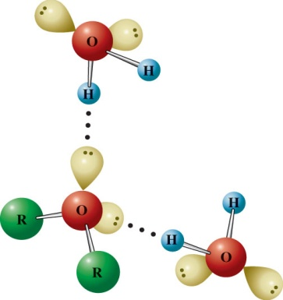**14.18 Physical and Chemical Properties of Ethers**

**Physical Properties:** The boiling points of ethers are similar to those of alkanes of comparable molecular mass and are much lower than those of alcohols of comparable molecular mass.

Ethers more soluble in water than alkanes of similar molar mass because ethers can hydrogen bond



**Chemical Properties:**

Ethers are Flammable, e.g., Diethyl ether has boiling point of 35oC and therefore a flash-fire hazard.

Ethers react slowly with oxygen from the air to form unstable hydroperoxides and peroxides.

Unreactive towards acids, bases and oxidizing agents (useful for organic reactions)

Like alkanes, ethers also undergo halogenation reactions

**Cyclic Ethers**

Contain the ether functional groups as part of a ring system (heterocyclic organic compounds).

**Heterocyclic organic compound**: a cyclic organic compound in which one or more of the carbon atoms in the ring have been replaced with atoms of other elements.

Important cyclic ethers:

**THF** : Useful as a solvent in that it dissolves many organic compounds and yet is miscible with water.

Polyhydroxy derivatives of the five-membered (**furan**) and six membered (**pyran**) carbohydrates are cyclic ether systems.



**14.20 Sulfur Analogs and Alcohols and Ethers**

R-SH ---- Thiol

R-S-R ---- Thioether

Lower boiling point than corresponding alcohols due to lack of hydrogen bonding

Strong disagreeable odor

Natural gas odor is due to added thiols

**-S- and -SH functional groups:**

**Thioether: R-S-R'**

**Thiol: R-S-H**

* Thiols are named in the same way as alcohols in the IUPAC system, except that the “–ol” becomes “-thiol.”
* The prefix thio- indicates the substitution of a sulfur atom for an oxygen atom.
* As in the case of diols and triols, the “-e” at the end of the alkane name is also retained for thiols.



**14.21 Sulfur Analogs of Ethers**

Thioethers (or sulfides): An organic compound in which a sulfur atom is bonded to two carbon atoms by single bonds.

* *General* formula: R—S—R.
* Like thiols, thioethers (or sulfides) have strong characteristic odors.
* Thiols are more reactive than their alcohol and ether counterparts. A carbon–sulfur covalent bond is weaker than a carbon–oxygen bond.
* Dimethyl sulfide is a gas at room temperature and ethyl methyl sulfide is a liquid.

Thiols and thioethers exbit functional group isomerism in the same manner that alcohols and ethers.

**Menthol: A Useful Naturally Occurring Terpene Alcohol; Ethers as General Anesthetics; Marijuana: The Most Commonly Used Illicit Drug; Garlic and Onions: Odiferous Medicinal Plants**

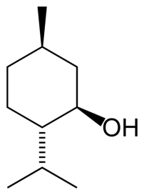 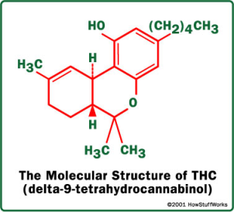 

**Menthol Marijuana Garlic and Onions**