**Chapter 13. Unsaturated Hydrocarbons**

**13.1 Unsaturated Hydrocarbons**

Unsaturated hydrocarbon: a hydrocarbon with one or more carbon–carbon multiple bonds (double bonds, triple bonds, or both).

* + Physical properties similar to those of saturated hydrocarbons.
  + Chemical properties are distinct.
  + Chemically more reactive than saturated hydrocarbons.
  + Reactivity of unsaturated hydrocarbons is due carbon–carbon multiple bond(s).

**Functional group**: Part of an organic molecule responsible for most of its chemical reactions.

**Unsaturated hydrocarbon functional group**: Carbon–carbon multiple bonds.

**Alkenes**: Contain one or more carbon–carbon double bonds

**Alkynes**: contain one or more carbon–carbon triple bonds

**Aromatic hydrocarbons**: A special type of “delocalized” bonding that involves a six membered carbon ring

**13.2 Characteristics of Alkenes and Cycloalkenes**



**Alkenes**: An alkene is an acyclic unsaturated hydrocarbon that contains one or more carbon – carbon double bonds.

Functional group: C=C group.

**Naming**: Names end with an “-ene” versus

The -ene ending means a double bond is present.

General molecular formula: CnH2n

Two simplest alkenes are ethene (C2H4) and propene (C3H6).

The arrangement of bonds about the carbon atom in alkanes is tetrahedral.

The arrangement of bonds about carbon atoms with double bonds in alkenes is trigonal planar.

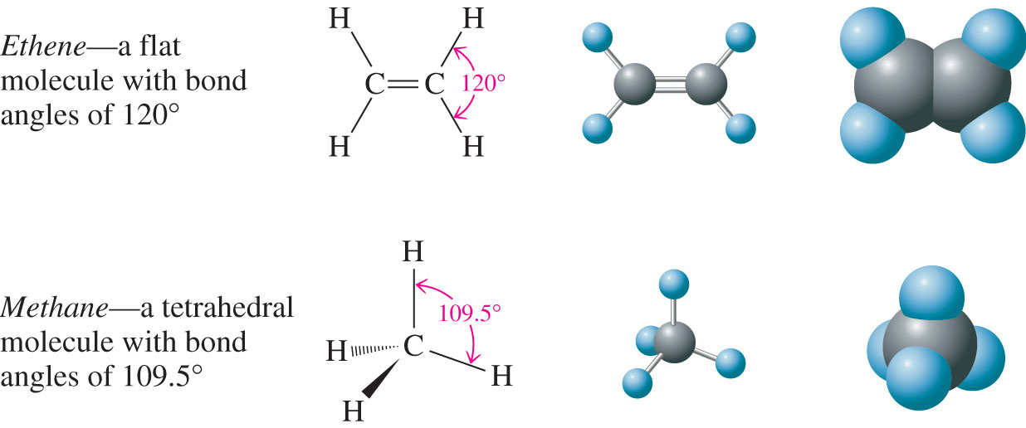

**Cycloalkanes**: A cyclic unsaturated hydrocarbon with one or more carbon–carbon double bonds within the ring system.



Cycloalkenes with only one double bond have the general molecular formula CnH2n-2.

The simplest cycloalkene: Cyclopropene (C3H4), a three-membered carbon ring system with one double bond.

Cycloalkenes with more than one double bond are possible but are not common.



**13.3 IUPAC Nomenclature for Alkenes and Cycloalkenes**

**IUPAC Rules**

**Rule 1**: Replace the alkane suffix *-ane* with the suffix *-ene*

**Rule 2**: Select as the parent carbon chain the longest continuous chain of carbon atoms that contains both carbon atoms of the double bond.

**Rule 3**: Number the parent carbon chain beginning at the end nearest to the double bond. If the double bond is equidistant from both ends of the parent chain, begin numbering from the end closer to a substituent.

**Rule 4**: Give the position of the double bond in the chain as a single number, which is the lower-numbered carbon atom participating in the double bond.

**Rule 5**: Use the suffixes *-diene, -triene, -tetrene*, and so on when more than one double bond is present in the molecule.

**Rule 6**: Do not use a number to locate the double bond in unsubstituted cycloalkenes with only one double bond because that bond is assumed to be between carbons 1 and 2.

**Rule 7**: In substituted cycloalkenes with only one double bond, the double-bonded carbon atoms are numbered 1 and 2 in the direction (clockwise or counterclockwise) that gives the first-encountered substituent the lower number.

**Rule 8**: In cycloalkenes with more than one double bond within the ring, assign one double with numbers 1 and 2 and the other double bonds the lowest numbers possible.

**Example**

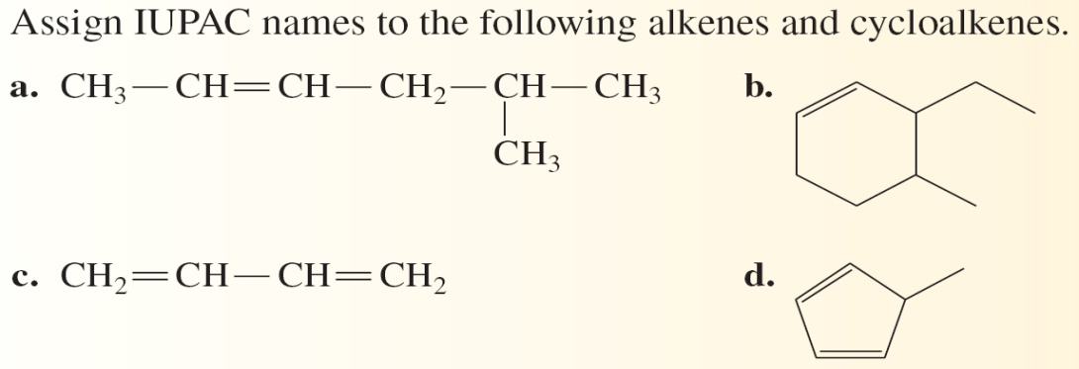

**Answers:**

**a. 5-Methyl-2-hexene**

**b. 3-Ethyl-4-methylcyclohexene**

**c. 1,3-Butadiene**

**d. 5-Methyl-1,3-pentadiene**

**Common Names** (Non-IUPAC Names):

Common names exist for alkenes

There is no scientific basis for assigning such names therefore one must have to memorize them

Two most common names for alkenes are:

* + CH2=CH2 - Ethylene (IUPAC name – Ethene)
  + CH2=CH2-CH3 – Propylene (IUPAC name – propene)

**Alkenes as Substituents**

Alkenes substituents are called alkenyl groups

Most Frequently encountered alkenyl groups:

* + Methylidene (one- carbon)- Common name: methylene
  + Ethenyl (two- carbon) - Common name: vinyl
  + 2-propenyl (three-carbon) - Common name: allyl

**13.4 Line-Angle Structural Formulas for Alkenes**

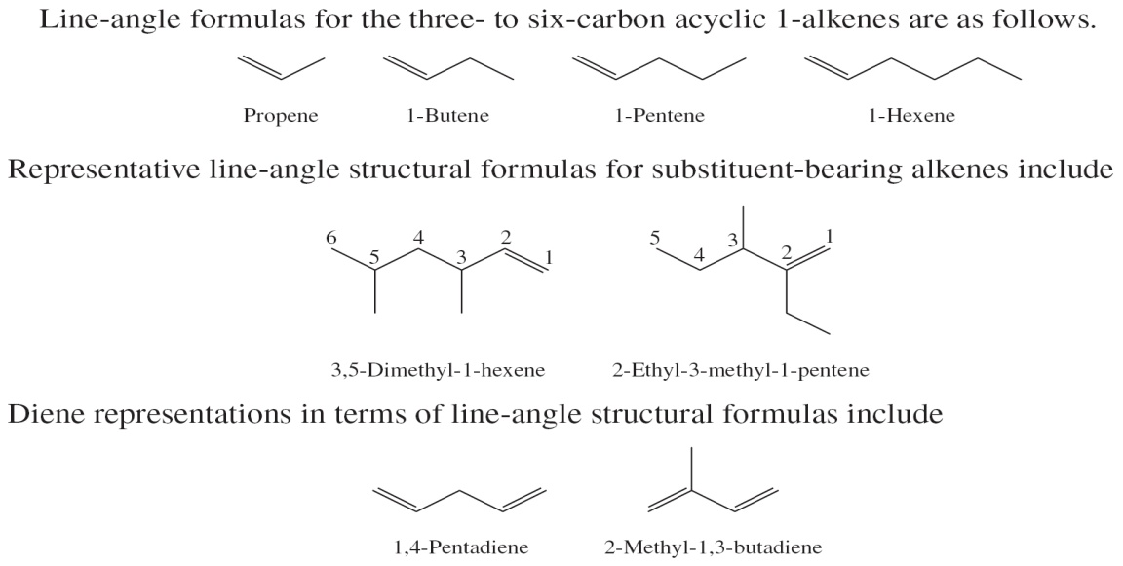

**13.5 Constitutional Isomerism in Alkenes**

Constitutional isomerism is possible in alkenes as for alkane. There are more alkene isomers possible for a given number of carbon atoms than there are alkane isomers

**Constitutional isomerism**: Same molecular formula but different structural formulas

**Geometric or positional stereoisomers**: Same number of carbon and hydrogen atoms but the position of the C=C is different **skeletal isomers** (Cis-Trans): Each C atom in the double bond contains the same substituent group but their positions are different.

**13.6 *Cis-Trans* Isomerism (Stereoisomerism) in Alkenes**

Cis–Trans isomerism in alkenes results from the structural rigidity associated with C=C double bonds. Rotation about the C=C (or CΞC) is not possible and the molecule is rigid.

**Isomers**

Isomers: Have same molecular formula and have different structural formula.

Cis-Trans Isomers:

* + Conditions: Each carbon atom in the double bond contains *t*wo different groups attached to them.
  + **Cis isomer**: Two similar groups on same side of double bond
  + Trans isomer: Similar groups on opposite sides of the double bond



**Example**: Identify the following as cis or trans isomers, or neither:

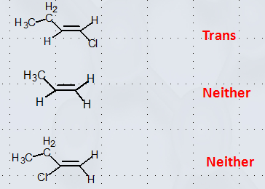

**13.7 Naturally Occurring Alkenes:**

**Pheromone**

A pheromone is a compound used by insects (and some other animals) to transmit a message to other members of the same species. Most know are for attracting sexual partners. Pheromones are often alkenes or alkene derivatives.

The biological activity of pheromones is coming from the combinations of C=C bonds in a cis or a trans configuration in the pheromone molecule.

Example: The sexual attractant of the female silkworm is a 16-carbon alkene derivative with a common name bombykol contains an -OH group.

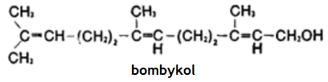

**Terpenes**

Organic compounds whose carbon skeleton is composed of two or more 5-carbon isoprene structural units Isoprene (2-methyl-1,3-butadiene) is a five-carbon diene.

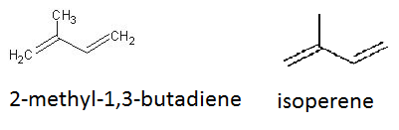

Terpenes are widely distributed in nature and >22,000 Terpenes are found in plant kingdom and are responsible for odors of many trees and plant fragrances found in citrus, cinnamon and many other spices.

**13.8 Physical Properties of Alkenes and Cycloalkenes**

Their hysical properties are similar to alkanes. The boiling and melting point of an alkene is usually lower than that of alkane with same number of carbon atoms alkenes with 2 to 4 carbon atoms are gases at room temperature. Unsubstituted alkenes with 5 to 17 carbon atoms are liquids. Alkenes with >17 C atoms are solids

**13.9 Chemical Reactions of Alkenes**

**Combustion**: Alkenes are very flammable and the combustion products are carbon dioxide and water.

**Addition Reactions**: Atoms or group of atoms are added to each a carbon atom of a multiple bond.

**Symmetric Addition Reactions**:

**Hydrogenation reaction**: In alkene hydrogenation a hydrogen atom is added to each carbon atom of a double bond.

* Catalyst (usually Ni or Pt)

**Halogenation reaction**: In alkene halogenation a halogen atom is added to each carbon atom of a double bond.

* No catalyst is needed

**Asymmetric Addition Reactions**:

Markovnikov’s Rule: When an unsymmetrical molecule HX (e.g., H-Cl, H-OH, H-F) reacts with an unsymmetrical alkene, the hydrogen atom from the HQ becomes attached to the unsaturated carbon atom that already has the most hydrogen atoms

Two types of unsymmetrical addition reactions:

* Hydration: Addition of Water
  + - H2SO4 is a catalyst that is why written on arrow.
    - Catalysts speed-up reactions.
* **Hydrohalogenation**

Addition of H-X (X = F, Cl, Br, I)

**13.10 Polymerization of Alkenes: Addition Polymers**

Polymers are macromolecules in which small units (monomers) are repeated again and again.

Examples: Polyethylene, polypropylene, polystyrene etc.

Polymers are huge molecules so their molecular formulas are not written.

The simplest repeating unit in parenthesis with “n” as subscript to shows the number of monomers.

Alkenes and substituted alkenes form is an addition polymer.

An addition polymer is a polymer in which the monomers simply “add together” with no other products formed besides the polymer.

Addition polymerization is similar to the addition reactions described previously except that there is no reactant other than the alkene or substituted alkene.

Example: Formation of polyethylene

**Butadiene-Based Addition Polymers**

Polymerization of 1,3-butadiene results in a butadiene polymer. These polymers contain double bonds (unsaturated polymers).

The polymers are flexible can be molded into shapes.

**Addition Copolymers**

**A copolymer** is a polymer in which two different monomers are present.

Examples:

* + Saran Wrap: a polymer chloroethene (vinyl chloride) and 1,1-dichloroethene.
  + Styrene–butadiene rubber: Leading synthetic rubber - contains 1,3-butadiene and styrene in a 3:1 ratio (major ingredient in automobile tires)

**13.11 Alkynes**

Alkyne: An acyclic unsaturated hydrocarbon that contains one or more carbon–carbon triple bonds.

Alkyne functional group: CΞC group

Naming: Names end with a suffix *-yne*

General formula: CnH2n-2

Simplest alkynes: C2H2, C3H4

**IUPAC Nomenclature for Alkynes**

**The rules for naming alkynes** are identical to those used to name alkenes except the ending -yne is used instead of -ene.

**Isomerism and Alkynes**

cis–trans isomerism not possiblebecause of the linearity (180º angles) about an alkyne’s triple bond. Constitutional isomers are possible—both relative to the carbon chain (skeletal isomers) and to the position of the triple bond (positional isomers).

**Physical Properties of Alkynes**

**Physical properties**: Similar to those of alkenes and alkanes Insoluble in water but soluble in organic solvents.

Densities less than that of water

Boiling points increase with molecular mass

Low-molecular-mass alkynes are gases at room temperature

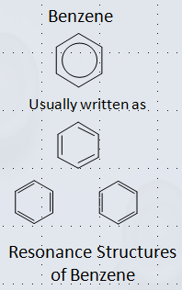**13.12 Aromatic Hydrocarbons**

Contains benzene ring with alternate double and single bonds

Double bonds are different than alkenes

These are called delocalized (=) bonds: All C-C bonds are similar

Resonance structures (differ only in arrangement of electrons

**13.13 Names for Aromatic Hydrocarbons**

Name the substituent followed by the name benzene.

When more than one substituent present, indicate the position by number followed by name of the substituent and the name benzene

* + No need to indicate position if there is only one substituent
  + Positions 1,2 are also know as Ortho positions
  + Positions 1,3 are also know as Meta positions

Positions 1,4 are also know as Para positions



**13.14 Aromatic Hydrocarbons: Physical Properties and Sources**

Insoluble in water

Soluble in non-polar solvents like hydrocarbons etc.

Less dense than water therefore floats on water

Benzene is colorless, flameless liquid, burns with sooty flame

Petroleum is the primary source of aromatic hydrocarbons

Gasoline has significant amount of benzene in it

**13.15 Chemical Reactions of Aromatic Hydrocarbons**

Aromatic hydrocarbons do not readily undergo the addition reactions because of delocalized bonding system (resonance)

Benzene undergoes substitution reactions

Two important types of substitution reactions for benzene and other aromatic hydrocarbons are alkylation and halogenation



Alkylation Halogenation

**13.16 Fused-Ring Aromatic Hydrocarbons**

Fused-ring aromatic hydrocarbons: Aromatic hydrocarbon whose structure contains two or more rings fused together and two carbon rings share a pair of carbon atoms

Examples:

