**Chapter 12. Saturated Hydrocarbons**

**12.1 Organic and Inorganic Compounds**

**Organic vs. Inorganic**

* **Organic chemistry**: Study of hydrocarbons (only carbon and hydrogen atoms) and their various derivatives.
  + Examples:natural gas, petroleum, plastics, rubbers, paper, carbohydrates (sugar, starch), proteins, enzymes, fatty acids, food stuff, drugs, textiles, etc.
* **Inorganic chemistry**: Study of all substances other than hydrocarbons and their derivatives.
  + Examples of inorganic compounds: sulfuric acid, nitric acid, ores and minerals, air, baking powder, caustic soda, table salt, metal alloys (brass, bronze), etc.

**12.2 Bonding Characteristics of the Carbon Atom**

* C-atom always makes total 4 Bonds
* The sharing of four valance electrons requires the formation of four covalent bonds which are represented by four lines as shown here.

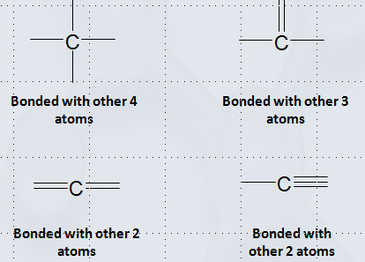

**12.3 Hydrocarbons and Hydrocarbon Derivatives**

* Hydrocarbon: Compound that contains only carbon and hydrogen atoms.
* Hydrocarbon derivative: Compound that contains carbon and hydrogen and one or more additional elements.
* Saturated hydrocarbon: Hydrocarbon with all carbon–carbon bonds are single bonds.
* Unsaturated hydrocarbon: Hydrocarbon with one or more carbon–carbon multiple bonds (double bonds, triple bonds, or both).

**12.4 Alkanes: Acyclic Saturated Hydrocarbons**

* **Alkanes**: Open chain (straight or branched) binary compounds of carbon and hydrogen.
* All bonds are single bonds.
* General formula: CnH2n+2 .

**12.5 Structural Formulas**

**Expanded Structural Formula**: A two-dimensional structural representation that depicts the bonding of all atoms in a molecule.

**Condensed Structural Formula**: Structural arrangements of different groupings (a central atom connected with other atoms) in a molecule.

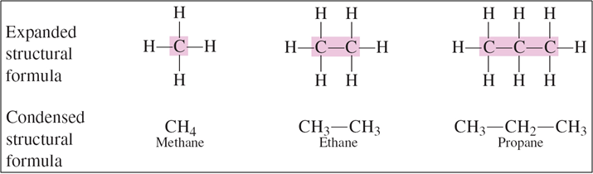

**Skeletal Structural Formula**: Structural arrangement of all bonded carbon atoms without showing the attached hydrogen atoms.



**12.6 Alkane Isomerism**

**Structural (Constitutional) Isomerism**

* Compounds having same molecular formula, but different structural arrangements (different connectivity of atoms) are called Isomers, and the phenomenon is known as isomerism.
* Space-filing models for the three isomeric C5H12 alkanes:
* 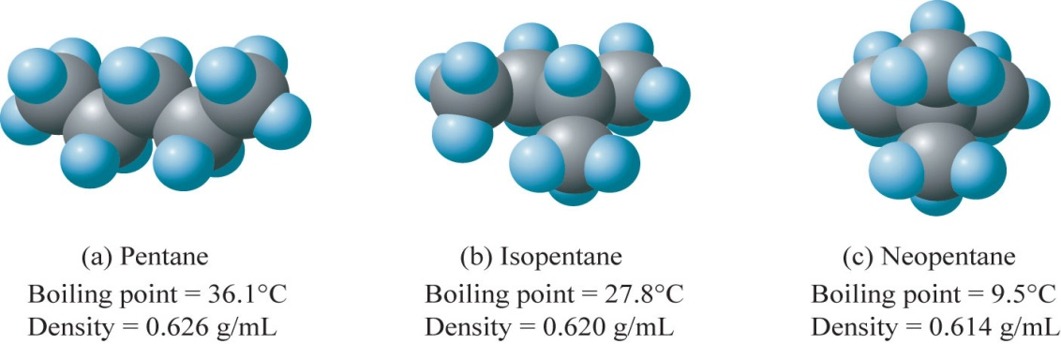

**Number of Isomers Possible for Alkanes of Various Carbon Chain Lengths**

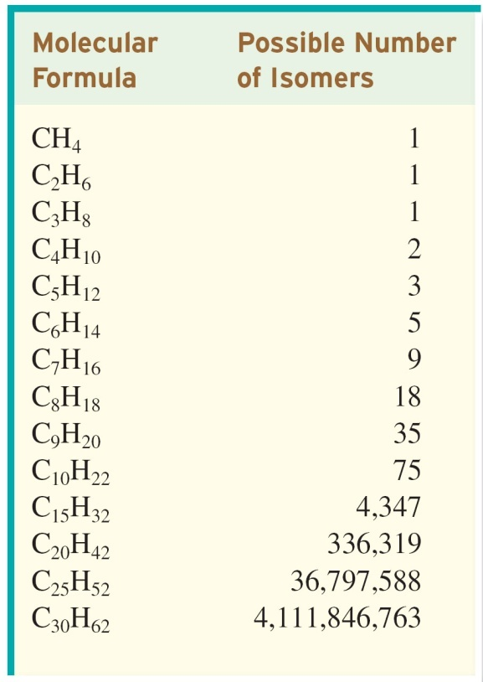

**12.7 Conformations of Alkanes**

* Conformation: At a given instant, the specific three dimensional spatial arrangement of atoms due to the rotation of C-C single bond in the same molecule.
* Different conformational structures result from C-C single bond rotation, but no breaking of bonds takes place.
* Different structural isomers result from different connectivity of atoms, which requires breaking and making of bonds in the same molecule.

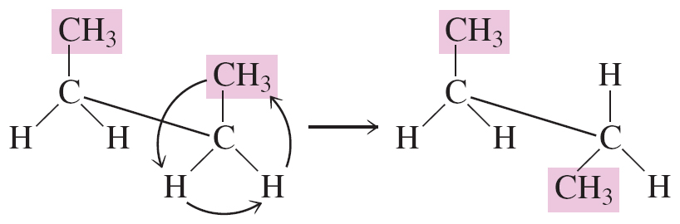

**12.8 IUPAC Nomenclature of Alkanes**

**Rules for Naming Stright-Chain Alkanes**

* Systematic approach for naming alkanes was introduced by the International Union of Pure and Applied Chemistry (IUPAC), and the rules are being updated periodically.
* The rules are applied to both types of alkanes:
  + **Straight chain** (continuous) alkanes
  + **Branched chain** (divided / substituted) alkanes
  + Substituent: an atom or group of atoms attached to a chain (or ring) of carbon atoms*.*
  + **Alkyl group**: the group of atoms that would be obtained by removing a hydrogen atom from an alkane.

**Rules for Naming Branched-Chain Alkanes**

* **Rule 1**: Identify the longest continuous carbon chain and name that chain as the parent
* **Rule 2**: Number the carbon atoms in the parent chain in such a way so that to give the lowest possible number for a substituent (alkyl group).
* **Rule 3**: If only one substituent present, name and locate it by number; then, prefix the number and name to that of the parent carbon chain.
* **Rule 4**: If two or more of the same kind of alkyl group are present in a molecule, indicate the number with a Greek numerical prefix  
  (di-, tri-, tetra-, penta-, and so forth). In addition, a number specifying the location of each identical group must be included. These position numbers, separated by commas, precede the numerical prefix. Numbers are separated from words by hyphens.
* **Rule 5**: When two kinds of alkyl groups are present on the same carbon chain, number each group separately, and list the names of the alkyl groups in alphabetical order.
* **Rule 6**: Follow IUPAC punctuation rules:

1. Separate numbers from each other by commas.
2. Separate numbers from letters by hyphens.
3. Do not add a hyphen or a space between the last-named substituent and the name of the parent alkane.

**Example**

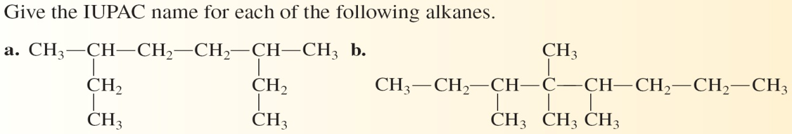

**Answer:**

**a. 3,6-Dimethyloctane**

**b. 3,4,4,5-Tetramethyloctane**

**12.9 Line-Angle Structural Formulas for Alkanes**

* Line-angle (Bond-Angle) structural formula:
  + A structural representation in which a line represents a carbon–carbon bond.
  + A carbon atom is understood to be present at every point where two lines meet ( at the intersection).
  + At the ends of each lines.

**Example:**

* Structures of branched-chain alkanes designated using line-angle structural formulas.

**Example**: The five constitutional isomers of C6H14.

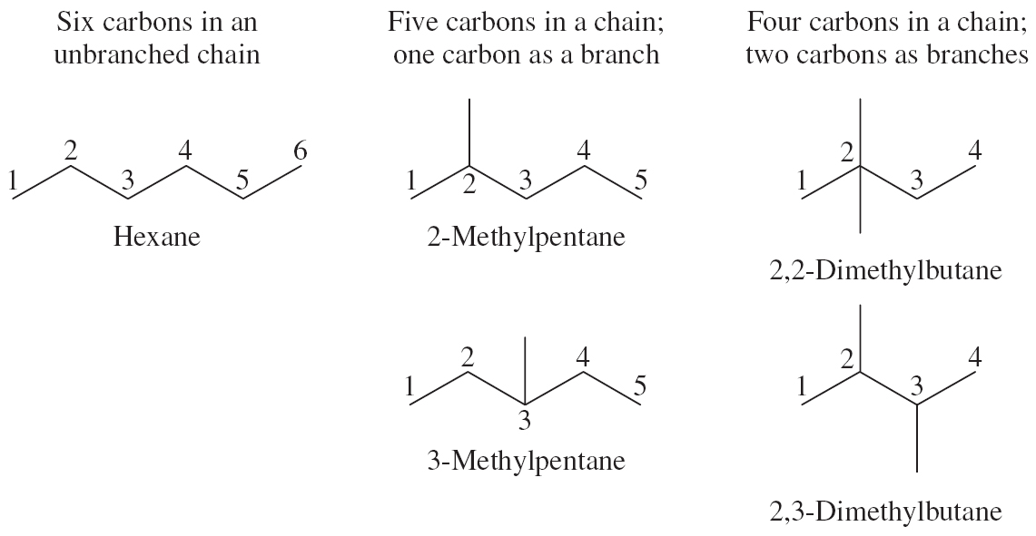

**12.10 Classification of Carbon Atoms**

Based on the skeletal structure of the C-atom in a hydrocarbon chain, each C-atom can be classified as follows:

* + **Primary**: If bonded with only one C- atom
  + **Secondary**: If bonded with other 2 C- atoms
  + **Tertiary**: If bonded with other 3 C-atoms
  + **Quaternary**: If bonded with other 4 C- atoms

**12.11 Branched-Chain Alkyl Groups**

**Continuous chain alkyl groups**: The simplest type of alkyl group with continuous chain of carbon atoms.

**Branched-chain alkyl groups**: Alkyl groups are added to the continuous parent chain of carbon atoms (Alkenes with branched-chain alkyl groups).

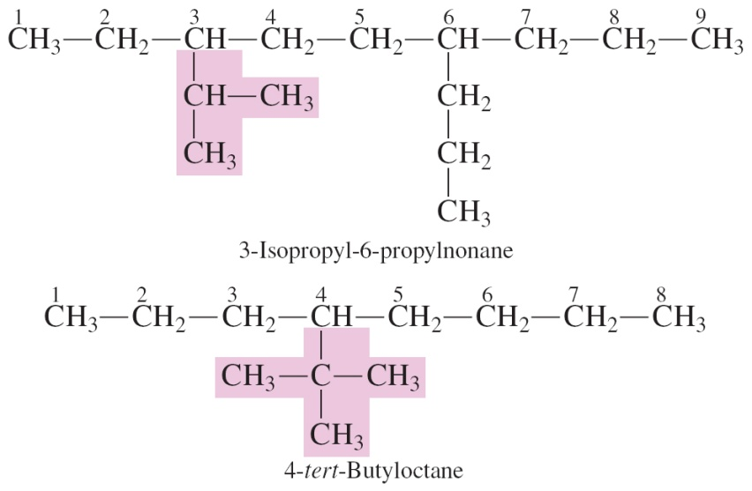

**12.12 Cycloalkanes**

Cycloalkanes are alkanes that contain a ring of three or more carbons.

General Formula of Cycloalkane: C*n*H2*n*

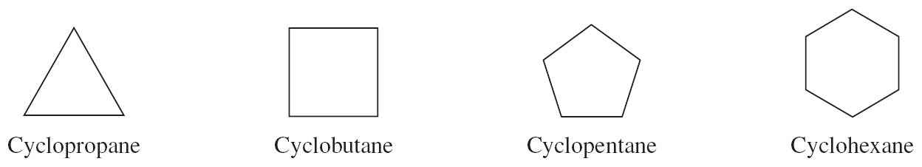

**12.13 IUPAC Nomenclature for Cycloalkanes**

* Count the number of carbons in the ring, and name the parent cyclic chain (just like an alkane).
* Add the prefix *cyclo* to the IUPAC name of the unbranched alkane, e.g., Cyclopentane
* Name any alkyl groups on the ring in the usual way
* Numbering conventions used in locating substituents on the ring:
  1. If there is just one ring substituent, it is not necessary to locate it by number.
  2. When two ring substituents are present, the carbon atoms in the ring are numbered beginning with the substituent of higher alphabetical priority and proceeding in the direction (clockwise or counterclockwise) that gives the other substituent the lower number.

When three or more ring substituents are present, ring numbering begins at the substituent that leads to the lowest set of location numbers. When two or more equivalent numbering sets exist, alphabetical priority among substituents determines the set used

.

3-Ethyl-1,1-dimethylcyclohexane

**Example**

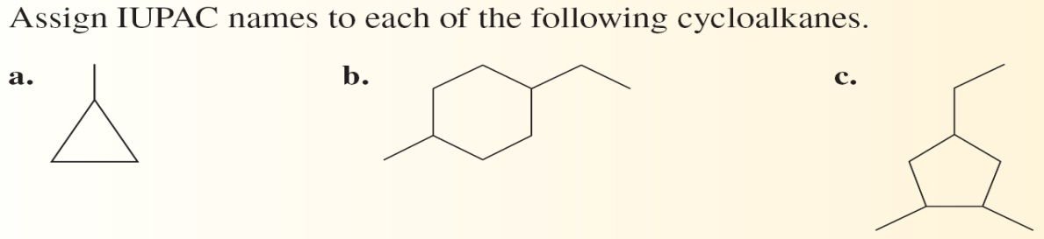

**Answers:**

1. **Methylcyclopropane**
2. **1-Ethyl-4-methylcyclohexane**
3. **4-Ethyl-1,2 dimethylcyclopentane**

**12.14 Isomerism in Cycloalkanes**

Cycloalkanes also exhibit stereoisomerism.

* + Stereoisomers have the same molecular and structural formulas but different orientations of atoms in space.
  + Several forms of stereoisomerism exist.

Di-substituted Cycloalkanes exhibit Cis-Trans isomerism.

* + Cis–trans isomers have the same molecular and structural formulas but different spatial orientations of atoms due to the restricted rotation about bonds.

***Cis-***is a prefix that means “on the same side.” In cis-1,2-dimethylcyclopentane, the two methyl groups are on the same side of the ring.

***Trans-*** is a prefix that means “across from.” In trans-1,2-dimethylcyclopentane, the two methyl groups are on opposite sides of the ring.

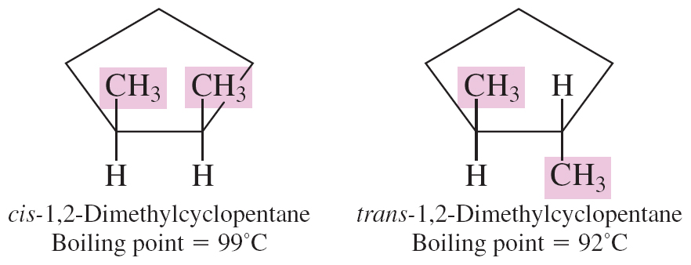

**12.15 Sources of Alkanes and Cycloalkanes**

**Natural Gas and Petroleum**

Natural Gas:

* + 50 - 90% Methane
  + 1 - 10% Ethane
  + Up to 8% Higher Alkanes (mostly Propane and Butanes)

Petroleum (crude oil):

* + Complex mixture of acyclic and cyclic hydrocarbons

**Petroleum Refining**

Refining: Isolation of soil, sand, sulfur, etc., from the crude oil and physical separation of the hydrocarbons mixture into several fractions.

Fractional Distillation: Process of separating different components from a mixture based   
on their boiling points.

**12.16 Physical Properties of Alkanes and Cycloalkanes**

**Solubility and Density**

**Solubility**: Follows the rule ‘like dissolves like’

* + Soluble in non-polar solvents e.g., in hexanes
  + Insoluble in polar solvents e.g., water, alcohol
  + Application: protective wax coating on fruits to prevent loss of water as well as from fungi or bacterial strain etc.

**Density**: Lighter than water

* + Densities of alkanes and cycloalkanes range from
  + 0.6 – 0.8 g/mL (water density at 4 degree C = 1.0 g/mL)
  + Practical illustration: quick spreading of oil spills in water.
  + Fire caused by floating oil can not be extinguished by water.

**Boiling Points**

The boiling points increase with an increase in the number of carbon atom in chain length or ring size.

Branching in carbon chain lowers the boiling point of an alkane.

Cycloalkanes have higher boiling points than their noncyclic counterparts with the same number of c-atoms

**12.17 Chemical Properties of Alkanes and Cycloalkanes**

Vigorous reaction with oxygen (usually from air)

Accompanied by the evolution of heat and light

Always an exothermic process

The final products of any complete combustion of hydrocarbons are:

* + Carbon dioxide and Water (vapor)
  + CH4 + 2O2 🡪 CO2 + 2H2O + Energy
  + 2C6H14 + 19O2 🡪 12CO2 + 14H2O + Energy
  + Incomplete / partial combustion results in a mixture of carbon dioxide and carbon monoxide with water (g)

**Halogenation**

Direct reaction with halogens (chlorine, bromine, iodine)

Substitution of one or more H-atoms of hydrocarbons by halogen atoms (substitution reaction of alkanes)

**12.18 Nomenclature and Properties of Halogenated Alkanes**

Halogenated Alkanes: Derivatives alkanes in which one or more hydrogen atoms are substituted by halogen atoms.

Halogenated cycloalkanes: Cycloalkane derivatives in which one or morehydrogen atoms are substituted by halogen atoms

These derivatives are named as:

* + Haloalkanes or Halocycloalkanes (IUPAC naming)
  + Alkyl Halides or Cycloalkyl halides (common naming)

**IUPAC Rules**

* Follow the same rules for naming alkanes / cycloalkanes
* Lowest locant number is given to the top priority group.
* Alkyl and halogen substituents have the same ranking.
* If 2 or more different substituents are present, the alphabetical order determines their priority.

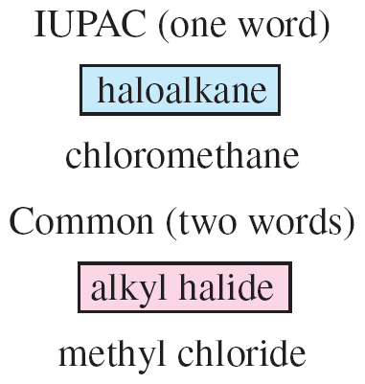

**Physical Properties of halogenated alkanes**

* Density: Many halogen derivatives are heavier than water.
* Polarity: They are mostly polar compounds (if unsymmetrical).
* Boiling Points: Generally higher than parent hydrocarbons.