**Chapter 4. Chemical Bonding: The Ionic Bond Model**  
**4.1 Chemical Bonds**

Almost all chemical substances are found as aggregates of atoms in the form of molecules and ions produced through the reactions of various atoms of elements except the noble-gas elements which are always found as mono-atomic gases.

**Chemical bond** is a term that describes the attractive force that is holding the atoms of the same or different kind of atoms in forming a molecule or ionic solid that has more stability than the individual atoms. Depending on the kinds of atoms participating in the interaction there seem to be three types of bonding:

**Ionic bonding**: Formed between many ions formed by metal and nonmetallic elements.

**Covalent bonding**: Formed between two atoms of non-metals.

**Metallic bond**: Formed between many atoms of metallic elements.

|  |  |  |  |
| --- | --- | --- | --- |
|  | **Ionic Compounds** | **Covalent Compounds** | **Metallic Compounds** |
|  | **Metal** and **non-meal** element combinations. | **Non-metal** and **non-meal** elements combinations. | **Metal** and **metal** element combinations. |
|  | **High melting brittle** crystalline solids. | **Gases, liquids, or waxy, low melting soft** solids. | **Conducting**, malleable, ductile and high melting solids. |
|  | Do not conduct as a solid but conducts **electricity** when **molten**. | **Do not** conduct electricity at **any state**. | **Conduct** as a solid and when molten. |
|  | Dissolved in water produce conducting solutions (**electrolytes**) and few are soluble in non-polar solvents. | Most are soluble in non-polar solvents and few in water. These solutions are non-conducting (**non-electrolytes**). | **Do not dissolve** in water. |

The differences in these three bonding types are mainly due to the number of valence election of the interacting atoms compared to noble gas elements. Noble gases show no inherent tendency to form any type of bonding apparently due to their closed valence shell electron configurations. Non-metals need only few electrons to achieve a closed shell where as metals need many electrons. We focus mainly on ionic and covalent bonding in this course.

**4.2 Valence Electrons and Lewis Symbols**

Valence electron configuration of an atom is important in understanding the nature of chemical bonding. Lewis electron-dot symbol is a simple representation of valence electrons around the atomic symbol with dots. E.g. Lewis symbols for the second row of elements in the periodic table are given below:

|  |  |  |  |  |  |
| --- | --- | --- | --- | --- | --- |
| **Li** | **[He]** 2s1(1 electron) |  | **N** | **[He]** 2s2, p3 (5 electrons) |  |
| **Be** | **[He]** 2s2(2 electrons) |  | **O** | **[He]** 2s2, p4 (6 electrons) |  |
| **B** | **[He]** 2s2, p1 (3 electrons) |  | **F** | **[He]** 2s2, p5 (7 electrons) |  |
| **C** | **[He]** 2s2, p2 (4 electrons) |  | **Ne** | **[He]** 2s2, p6 (8 electrons) |  |

**Predicting ionic charge:**

**Cations:**

Remove all electrons form symbol.. Cation charge is equal to electrons removed.

**Anions:**

Add additional electrons fill valence shell of the symbol.. Anion charge is equal to electrons added.

**Using Lewis dot symbols predict the following:**

Charge of the cations formed by Group I A: alkali metals (Li, Na, K, Rb, Cs)

Common Lewis symbol of Group I A  becomes  (**Ans. +1**)

**Charge of the cations** formed by Group II A: alkali earth metals (Be, Mg, Ca, Ba) (**Ans. +2**)

**Charge of the anions** formed by Group VII A: halogens (F, Cl, Br, I)

Common Lewis symbol of Group VII A  becomes (**Ans. -1**)

**Predicting number of covalent bonds:**

Number of covalent bonds formed by an element is number of single (lone) electrons in the Lewis symbol.

Number of covalent bonds formed by Group IV A: C, Si, Ge

Common Lewis symbol of Group IV A  and number of lone electrons (**Ans. Four**)

**4.3 The Octet Rule**

An atom with eight electrons in the valence shell is a stable atom. All noble gas elements have an octet in their valence shell except the helium atom. When atoms have less than eight electrons, they tend to react and attain an octet of electrons forming more stable compounds.

**Covalent bonding**: Attractions formed when non-metals share electrons to achieve an octet.

**Ionic bonding**: Electrical attractions of ions formed by of **metal** and **nonmetal** elements when they lose and gain electrons forming **cations** and **anions** with octets, respectively.

**Metallic bond**: Attractions formed when metals with fewer valence electrons share electrons among many metal atoms.

**4.4 The Ionic Bond Model**

An ionic compound is made up of two or more ions are held next to each other by electrostatic attraction. One of the ions has a positive charge (called a "cation") and the other has a negative charge ("anion"). **Mono-atomic ions** called cations are usually formed by metal atoms and anions from the non-metals. The **polyatomic** **ions** which are charged particles with more than one atom are formed by various combinations of metal and nonmetal elements. The formations of mono-atomic or polyatomic ions from various **metal** and **nonmetals** are explained by the tendency of single atoms to achieve a **closed shell electron configurations.**

Sodium metal, Na(*s*) reacts with chlorine (non-metal) gas, Cl2(*g*) in a violently exothermic reaction where heat is given out to produce NaCl (composed of Na+ and Cl- ions):

2Na(*s*) + Cl2(*g*) → 2NaCl(*s*)

Na(*s*) lose an electron and becomes a Na+ (sodium ion)which is isolectronic to Ne and Cl2(*g*) first breaks up to atomic chlorine which then picks the electron lost by the sodium and produce a Cl- (chloride ion) isoelectronic to Ar.

Lewis dot symbols are useful in showing the ways in which non-noble gas electron configurations could be achieved by losing or gaining electrons.

**4.5 The Sign and Magnitude of Ionic Change**

**Metals** can **lose** all valence electrons and can achieve closed shell electron configuration of preceding noble gas element. E.g. Lithium-Li could lose its one valance electron and become like helium-He forming a **stable** **cation** - **Li+**.

**Non-metals** can gain elections and achieve closed shell electron configuration of next noble gas element. E.g. Fluorine-F could can gain an electron and become like neon-Ne forming a **stable anion**,- **F-**. Non-metals need a metal to gain electrons and vice versa. In the process ions are formed and they are held together by the attractive forces between cation and ions in the **ionic solid**.

|  |  |
| --- | --- |
|  | **Predicting charge of Ions of Representative Elements** |
| **Periodic Table Group Number** |  |
| **Common Lewis electron-dot symbols** |
| **Lewis electron-dot symbols**  **2nd period elements** |
| **Lewis electron-dot symbols**  **the ions of 2nd period** |
| **`Charge on ions of 2nd period elements.** |
|  |

**4.6 Lewis Structures for Ionic Compounds**

|  |  |
| --- | --- |
|  | **Lewis Structure of Ions of Representative Elements** |
| **Periodic Table Group Number** |  |
| **Lewis electron-dot symbols**  **2nd period elements** |
| **Lewis electron-dot symbols**  **the ions of 2nd period** |
| **Lewis symbols of ions of 2nd period** |
|  |

In the formation of calcium bromide, CaBr2 Use electron-dot symbols to show the transfer of electrons from calcium atoms to bromine atoms to form ions with noble gas configurations.  Name the compound formed.

**4.7 Chemical Formulas for Ionic Compounds**

The cation is always named first.    
Cations can be metals or polyatomic ions

For metals that have only one possible charge (valency) the name of the metal is used.   
Examples are Group I metals, Group II metals, Aluminum, Zinc, Silver

For metals that can have more than one charge (valency) the name of the metal is succeeded by the valency in capital Roman numerals in brackets OR by using the suffix -ous for the lowest valency and -ic for the highest valency and sometimes with the Latinised name for the metal.  
 Anions can be a negatively charged element or a polyatomic ion    
 Negatively charged elements have the suffix -ide   
Examples are oxide (O2-), sulfide (S2-), fluoride (F-), chloride (Cl-), bromide (Br-), iodide (I-), nitride (N3-), hydride (H-)    
 Polyatomic ions which include oxygen in the anion have the suffixes -ate or -ite. "ate" means there is more oxygen in the anion than one ending in "ite"   
 Examples: sulfate (SO42-) has more oxygen than sulfite (SO32-), nitrate (NO3-) has more oxygen in the anion than nitrite (NO2-)   
 Other examples are carbonate (CO32-), phosphate (PO43-) and permanganate (MnO4-)   
 Exception: OH- is named hydroxide

Exercise 01.  Name the following ions:   
K+     Ca2+     Zn2+     Br-     Li+     S2-   
[**Answer**](http://chem.latech.edu/~snowchem/chem120/C5HW25BB.jpg)

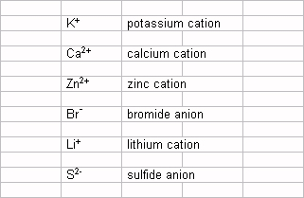

Exercise 02.  Name the following ions:   
Na+     Mg2+     Al3+     Cl-    O2-     N3- [**Answer**](http://chem.latech.edu/~snowchem/chem120/C5HW26BB.jpg) 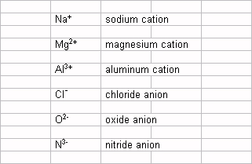

Exercise 03.  Name the following ions:   
Fe2+     Cu+     I-     Fe3+     Cu2+     Sn2+     Sn4+     Ag+   
[**Answer**](http://chem.latech.edu/~snowchem/chem120/C5HW27BB.jpg) 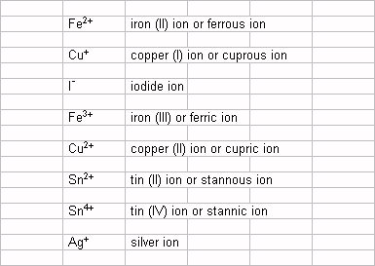

Exercise 04.  Use electron-dot symbols to show the transfer of electrons from calcium atoms to bromine atoms to form ions with noble gas configurations.  Name the compound formed.   
[**Answer**](http://chem.latech.edu/~snowchem/chem120/C5HW01AA.jpg) 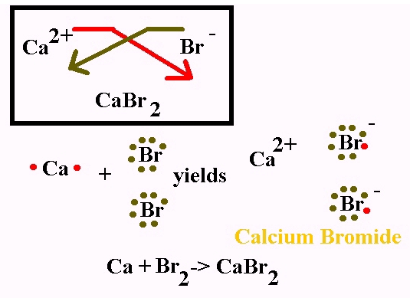

Exercise 05.  Use electron-dot symbols to show the transfer of electrons from magnesium atoms to sulfur atoms to form ions with noble gas configurations.  Name the compound formed.   
[**Answer**](http://chem.latech.edu/~snowchem/chem120/C5HW02BB.jpg) 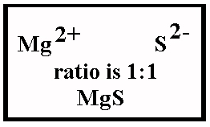

Exercise 06.  Use electron-dot symbols to show the transfer of electrons from aluminum atoms to sulfur atoms to form ions with noble gas configurations.  Name the compound formed.   
[**Answer**](http://chem.latech.edu/~snowchem/chem120/C5HW03BB.jpg)

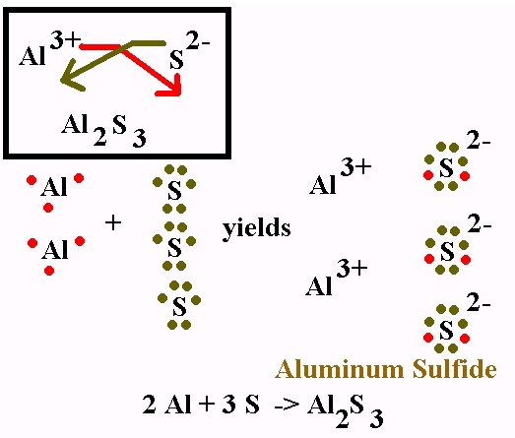

Exercise 07.  Use electron-dot symbols to show the transfer of electrons from magnesium atoms to phosphorous atoms to form ions with noble gas configurations.  Name the compound formed.   
[**Answer**](http://chem.latech.edu/~snowchem/chem120/C5HW04BB.jpg)  
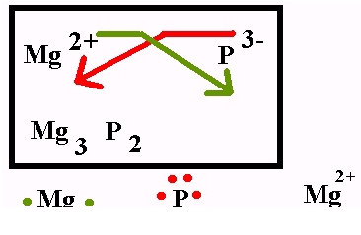

**4.8 The Structure of Ionic Compounds**

Sodium metal, Na(*s*) reacts with chlorine (non-metal) gas, Cl2(*g*) in a violently exothermic reaction where heat is given out to produce NaCl (composed of Na+ and Cl- ions):

2Na(*s*) + Cl2(*g*) → 2NaCl(*s*)

Na(*s*) lose an electron and becomes a Na+ (sodium ion)which is isolectronic to Ne and Cl2(*g*) first breaks up to atomic chlorine which then picks the electron lost by the sodium and produce a Cl- (chloride ion) isoelectronic to Ar.

**4.9 recognizing and Naming Binary Ionic Compounds**

The differences in these three bonding types are mainly due to the number of valence election of interacting atoms compared to noble gas elements. Noble gases show no inherent tendency to  
Chemistry at a Glance: Ionic Bonds and Ionic Compounds

**Naming Compounds and Writing Formulas of Compounds**

A substance is given **systematic name** of substance according to certain rules. Before the rules are made **common names** was given without following systematic rules. The "shorthand" symbol for a compound is its formula. Formula gives types atoms and number each one in the Chemical compound.

**Naming Ionic Compounds**

Names of ionic compounds are based on names of the ions making them. Ions are classified as monatomic or polyatomic.

In the Stock system a Roman numeral indicates the charge of the cation. This system is preferred over the older "common nomenclature" system.

**Charges on monatomic ions of metals and nonmetals**

**Symbols and Names of monoatomic ions:**

**"Representative = Fixed Charge " ions:**

|  |  |  |  |  |
| --- | --- | --- | --- | --- |
| **Symbol** | **Name** |  | **Symbol** | **Name** |
| H+ | Hydrogen ion |  | H- | Hydride ion |
| Li+ | Lithium ion |  | F- | Fluoride ion |
| Na+ | Sodium ion |  | Cl- | Chloride ion |
| K+ | Potassium ion |  | Br- | Bromide ion |
| Be2+ | Beryllium ion |  | I- | Iodide ion |
| Mg2+ | Magnesium ion |  | O2- | Oxide ion |
| Ca2+ | calcium ion |  | S2- | Sulfide ion |
| Ba2+ | barium ion |  | N3- | Nitride ion |
| Zn2+ | zinc ion |  | P3- | Phosphide ion |

**"Variable Charge" Cations**

|  |  |  |  |  |  |  |
| --- | --- | --- | --- | --- | --- | --- |
| **Symbol** | **(Stock system)** | **Common** |  | **Symbol** | **(Stock system)** | **Common** |
| Cu+ | copper(I) | cuprous |  | Hg22+ | mercury(I) | mercurous |
| Cu2+ | copper(II) | cupric |  | Hg2+ | mercury(II) | mercuric |
| Fe2+ | iron(II) | ferrous |  | Pb2+ | lead(II) | plumbous |
| Fe3+ | iron(III) | ferric |  | Pb4+ | lead(IV) | plumbic |
| Sn2+ | tin(II) | stannous |  | Co2+ | cobalt(II) | cobaltous |
| Sn4+ | tin(IV) | stannic |  | Co3+ | cobalt(III) | cobaltic |
| Cr2+ | chromium(II) | chromous |  | Ni2+ | nickel(II) | nickelous |
| Cr3+ | chromium(III) | chromic |  | Ni4+ | nickel(IV) | nickelic |
| Mn2+ | manganese(II) | manganous |  | Au+ | gold(I) | aurous |
| Mn3+ | manganese(III) | manganic |  | Au3+ | gold(III) | auric |

**Symbols and Charges for Polyatomic Anions**

|  |  |  |  |  |
| --- | --- | --- | --- | --- |
| **Formula** | **Name** |  | **Formula** | **Name** |
| NO3- | nitrate |  | CO32- | carbonate |
| NO2- | nitrite |  | SO42- | sulfate |
| CN- | cyanide |  | SO32- | sulfite |
| MnO4- | permanganate |  | PO43- | phosphate |
| OH- | hydroxide |  | PO33- | phosphite |
| O22- | peroxide |  | ClO4- | perchlorate |
| HCO3- | hydrogen carbonate(bi carbonate) |  | ClO3- | chlorate |
| HSO4- | hydrogen sulfate (bisulfate) |  | ClO2- | chlorite |
| HSO3- | hydrogen sulfite (bisulfite) |  | ClO- | hypochlorite |
| HPO42- | hydrogen phosphate |  | CrO42- | chromate |
| H2PO4- | dihydrogen phosphate |  | Cr2O72- | dichromate |
| C2H3O2- | acetate |  |  |  |

**Writing Formulas of Ionic Compounds**

For ionic compounds, the name of the positive ion (cation) is given first, followed by the name of the negative ion (anion). There for conversion of name to formula is easy if you know the metal and nonmetal ion symbols and charges. Use the periodic table to decide the charge on both the cation and anion (or the tables) and determine the formula of the compound(s) formed in each case. For transition metals the common ionic charges are given in after the metal name in parenthesis.

Writing basic ionic compound formulas.

Examples: lithium sulfide; lithium =Li+1 ; sulfide =S-2

Write ions on a line: Li+1 S-2

Then remove cation and anion charges and exchange them without charge as subscripts on the metal and nonmetal

Li+1 S-2becomes Li2S1

Remember we omit "1" from the subscript **formula becomes Li2S**

**Problem**: What is the formula of the following compounds given their names?

1. Potassium chloride
2. Magnesium bromide
3. Magnesium nitirde

**Answer**: First get the formula of ions in the compound. Potassium consists of cation K+ and chloride Cl-. Look in the table to get charges on the ions and one need to balance the opposite charges. If charges are equal already formula has 1:1 anions and cation like in K+ and Cl-, therefore formula become KCl. If charges are different like in Mg2+ and N3- to get the formula usually cross multiply with charges to obtain 3 Mg2+ and 2 N3-) and drop the charges and write formula Mg3N2.

* 1. Potassium chloride (one K+ and one Cl-) KCl
  2. Magnesium bromide (one Mg2+ and two Br-) MgBr2
  3. Magnesium nitride (three Mg2+ and two N3-) Mg3N2

**Problem:** Give formula of following ionic compounds

|  |  |  |
| --- | --- | --- |
| a) sodium chloride | b) aluminum phosphate | c) magnesium fluoride |
| d) potassium nitrate | e) calcium sulfate | f) mercury(II) chloride |
| g) iron(II) chloride | h) cobalt(III) nitrate | i) potassium chromate |

**Answers:**

|  |  |  |
| --- | --- | --- |
| a) NaCl | b) AlPO4 | c) MgF2 |
| d) KNO3 | e) CaSO4 | f) Hg Cl2 |
| g) FeCl3 | h) Co(NO3)3 | i) KmnO4 |

**Problem:** Give names of following ionic compounds

|  |  |  |
| --- | --- | --- |
| a) iron(II) bromide | b) copper(II) sulfate | c) Sodium phospate |
| d) Sodium sulfite | e) Iron (II) nitrate | f) lithium carbonate |
| g) Gold (II) chloride | h) calcium bisulfate | i) potassium bicarbonate |

**Answers**:

|  |  |  |
| --- | --- | --- |
| a) FeBr2 | b) CuSO4 | c) Na3PO4 |
| d) Na2SO3 | e) Fe(NO3)2 | f) Li2CO3 |
| g) AuCl2 | h) Ca(HSO4)2 | i) KHCO3 |

**4.10 Polyatomic Ions**

POLYATOMIC IONS:   
Polyatomic ions are groups of atoms that

Some Common Polyatomic Ions

|  |  |  |  |  |  |
| --- | --- | --- | --- | --- | --- |
| [Hydronium](http://chem.latech.edu/~snowchem/chem120/lewis/H3O.jpg) | H3O+ |  |  |  |  |
| [Ammonium](http://chem.latech.edu/~snowchem/chem120/lewis/NH4.jpg) | NH4+ | Chlorate | ClO3- | Peroxide | O2-2 |
| Acetate | CH3COO-  or  C2H3O2- | [Perchlorate](http://chem.latech.edu/~snowchem/chem120/lewis/CLO4.jpg) | ClO4- | [Chromate](http://chem.latech.edu/~snowchem/chem120/lewis/CRO4.jpg) | CrO4-2 |
| [Nitrate](http://chem.latech.edu/~snowchem/chem120/lewis/NO3.jpg) | NO3- | [Permanganate](http://chem.latech.edu/~snowchem/chem120/lewis/MNO4.jpg) | MnO4- | [Dichromate](http://chem.latech.edu/~snowchem/chem120/lewis/CR2O7.jpg) | Cr2O7-2 |
| [Nitrite](http://chem.latech.edu/~snowchem/chem120/lewis/NO2.jpg) | NO2- | [Carbonate](http://chem.latech.edu/~snowchem/chem120/lewis/CO3.jpg) | CO3-2 | Silicate | SiO3-2 |
| [Hydroxide](http://chem.latech.edu/~snowchem/chem120/lewis/OH.jpg) | OH- | [Sulfate](http://chem.latech.edu/~snowchem/chem120/lewis/SO4.jpg) | SO4-2 | [Phosphate](http://chem.latech.edu/~snowchem/chem120/lewis/PO4.jpg) | PO4-3 |
| Hypochlorite | ClO- | [Sulfite](http://chem.latech.edu/~snowchem/chem120/lewis/SO3.jpg) | SO3-2 | Arsenate | AsO4-3 |
| Chlorite | ClO2- | [Thiosulfate](http://chem.latech.edu/~snowchem/chem120/lewis/S2O3.jpg) | S2O3-2 | Arsenite | AsO3-3 |
| [Cyanide](http://chem.latech.edu/~snowchem/chem120/lewis/CN.jpg) | CN- | Thiocyanate | SCN- | Borate | BO3-3 |
| [Bicarbonate](http://chem.latech.edu/~snowchem/chem120/lewis/HCO3.jpg) | HCO3- | [Bisulfate](http://chem.latech.edu/~snowchem/chem120/lewis/HSO4.jpg) | HSO4- | Bisulfite | HSO3- |
| Memorize the polyatomic ion names and formulas that are in RED boxes. | | | | | |

Rules for Naming Ionic Compounds Containing Polyatomic Ions   
Polyatomic ions are ions which consist of more than one atom.   
For example, nitrate ion, NO3- contains one nitrogen atom and three oxygen atoms.   
Atoms in a polyatomic ion are usually covalently bonded, and therefore stay together as a single, charged unit.

Rule 1. The cation is written first in the name; the anion is written second in the name.

Rule 2. When the formula unit contains two or more of the same polyatomic ion, that ion is written in parentheses with the subscript written outside the parentheses.

Note: parentheses and a subscript are not used unless more than one of a polyatomic ion is present in the formula unit (e.g., the formula unit for calcium sulfate is "CaSO4" not "Ca(SO4)").

Rule 3. If the cation is a metal ion with a fixed charge, the name of the cation is the same as the (neutral) element from which it is derived (e.g., Na+ = "sodium"). If the cation is a metal ion with a variable charge, the charge on the cation is indicated using a Roman numeral, in parentheses, immediately following the name of the cation (e.g., Fe3+ = "iron(III)").

Rule 4. If the anion is a monatomic ion, the anion is named by adding the suffix -ide to the root of the element name (e.g., I- = "iodide").

Note: Greek prefixes are not used to indicate the number of atoms, or polyatomic ions, in the formula unit for the compound (e.g., Ca(NO3)2 is named "calcium nitrate" not "calcium dinitrate"

Exercise 14.  Name the following ionic compounds:

|  |  |  |  |  |  |
| --- | --- | --- | --- | --- | --- |
| KNO2 | LiCN | NH4I | NaNO3 | KMnO4 | CaSO4 |
| [**Answer**](http://chem.latech.edu/~snowchem/chem120/C5HW18BB.jpg) | | | | | |
| NaHSO4 | Al(OH)3 | Na2CO3 | KHCO3 | NH4NO2 | Ca(HSO4)2 |
| [**Answer**](http://chem.latech.edu/~snowchem/chem120/C5HW19BB.jpg) | | | | | |
| Na2HPO4 | (NH4)3PO4 | Al(NO3)3 | NH4NO3 |  |  |
| [**Answer**](http://chem.latech.edu/~snowchem/chem120/C5HW20BB.jpg) | | | | | |
| Li2CO3 | Na2Cr2O7 | Ca(C2H3O2)2 | NH4C2H3O2 |  |  |
| [**Answer**](http://chem.latech.edu/~snowchem/chem120/C5HW21BB.jpg) |  |  |  |  |  |

**4.11 Chemical Formulas and Names for Ionic Compounds Containing Polyatomic Ions**  
Chemistry at a Glance: Nomenclature of Ionic Compounds  
Chemical Connections: Fresh Water, Seawater, Hard Water, and Soft Water: A Matter of Ions; Tooth Enamel: A Combination of Monoatomoc and Polyatomic Ions