The roles of models in understanding science

Teacher’s Version

NOS/STSE Features | 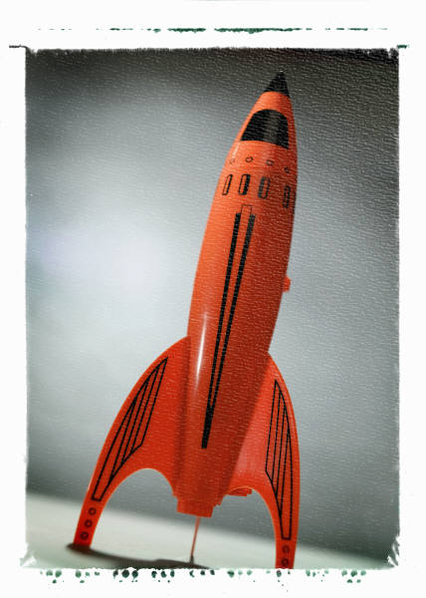
- A model can be regarded as a representation of an idea, an event, a process or a system.

- Every model has its strengths and weaknesses.

- The strengths and weaknesses of a model depend on the context or purpose.

- A model is not a direct copy of reality.

Table of Contents
Introduction | (i)
Activity 1: The most helpful map | P.1
Activity 2: The three states of water | P.2
Activity 3: Which model is the best? | P.4
Further Exercise/ Homework Exercise | P.5
Appendix: Lesson Plan | P.7

Introduction
Rationale
(a) What is a ‘model’?
A model can be regarded as a representation of an idea, an event, a process or a system.
Models in science are created to test ideas. They will change dramatically as ideas develop. Models also help us to represent our ideas , yet they are subject to some limitations. Therefore, a model is not a direct copy of reality.
In order to better serve the purpose, when people develop models, it is most common that they will highlight the more relevant areas selectively while neglecting less important aspects.

(b) What we have learnt about students’ concepts of models:
- Some students regard models as copies of reality and they think that the goodness of a model should be judged by its similarity to the real situation.
- They prefer simpler models, even when they know of more advanced models (e.g. they might still prefer a shell model of a molecule when the teacher tries to explain orbital hybridization.)
- They may fail to appreciate the scope and limitations of different models or ways of representation. As a result, they may not be able to choose the appropriate model to help them to solve a problem. (e.g. When students fail to see redox in terms of gain of oxygen, they might feel difficulty in understanding that carboxylic acid is the oxidation product of an alkanal.)
- They may confuse models (e.g. Arrhenius vs Bronsted-Lowry models of acid/base.). This may be due to the quality of textbooks which also do not differentiate these models clearly. Example: ‘When HCl dissolves in water, it releases hydrogen ions as the only positive ions. Because the chloride ion is a very weak conjugate base, it is unlikely to accept the proton. Therefore HCl is a strong acid.’
- They may place greater reliance on the material or concrete model than on other models (e.g. some students insist that the ball-and-stick model is inferior to the space-filling model).
- They may receive wrong messages from models. For example, students may wrongly conceive from a 3D model of NaCl(s) that each sodium ion is only bonded to six chloride ions. This is due to their literal interpretation of the 3D model of NaCl where they see the “sticks” representing ‘ionic bonds’. (The rods are simply supports, not the representations of bonds. This is probably a confusion between the ionic model and the ball-and-stick model.)

(c) Aims of this package
It is hoped that students can understand (i) the role of models in making sense of scientific knowledge; (ii) the scope and limitation of different models in representing the physical world.

Level of study Number of lessons
Form 4 – Form 5 (Activities 1 to 2) 2 lessons (each lesson 35-40 minutes)
Form 6 – Form 7 (Activities 1 to 3)
[Related Topic: Covalent Bonding (This could be a round-up lesson for the topic); Organic chemistry (This could be an introductory session to the topic)]

Contents:
- Introducing the ideas relating to Models to students, exemplified by the different types of maps we use in daily life.
- Introducing the uses of models in science through an examination of water as ‘particles’ and water as ‘molecules’.
- A re-examination of different chemical models. Students will work out the benefits and drawbacks of different models.

Teaching package includes
1. Worksheet (Teacher’s Version and Student’s version)
2. A Teaching PowerPoint

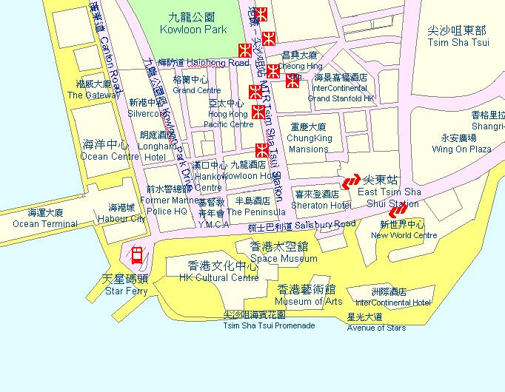 | Activity 1  The most helpful map  Key ideas: (i) Definition of models as representations of an idea, an event, process or system. (ii) When people develop a model, they will selectively highlight the more relevant areas while neglecting something less important in that particular context. (iii) Every model has its strengths and weaknesses.

Q1 Which types of map do you think is the best? Explain?
(Notes: Students should be encouraged to express their views.)
(Slide 3: Map showing Tsim Sha Tsui rail station exits

Slide 4: MTR system map
Slide 5: Geographic map of the MTR)
Notes: After some brainstorming from students, teacher (or better students) may bring out that:
- ‘Best’ can be defined in terms of either how similar the map is to reality or how useful the map is. (Skip the realist and instrumentalist view of science knowledge.) For example, the geographic map (slide 5) may not be helpful at all if you get lost in a street or if you want to know how to travel by MTR from Prince Edward station to North Point station. However, the MTR system map (slide 4) is useful, but it doesn’t necessary tell the distance between stations. It would be wrong to believe that the map is drawn to scale.
- A map can be a model of the geography of HK. The MTR map is a model of the routes travelled by MTR trains.
A model can be regarded as a representation of an idea, an event, a process or a system.
Q2 When people construct maps, they do not draw everything they see? Why not?
When people develop a model, it is common that they will selectively highlight the more relevant areas while neglecting something less important.

(Key question: when people draw these maps, do they copy everything they see? If not, what criteria guide their drawing/selection?)

[Notes: In devising the MTR system map (slide 4), the designer only focuses on the names of different stations and highlights how to change from one line to another (satellite maps, no matter how accurate they are, cannot do this). Other information such as the name of the streets are neglected. However, such delibrate selectivity actually makes the MTR map better for its purpose. Therefore, in order to better serve the purpose, when people develop models, it is most common that they will highlight the more relevant areas selectively while neglecting something less important.]
Every model has its strengths and weaknesses.

Activity 2  The three states of water  Key ideas: Strengths and weaknesses of a model depend on the context or purpose. Therefore teachers will need to ascertain the value of models that students have learnt in their junior forms – they are not wrong, but serve different purposes. | 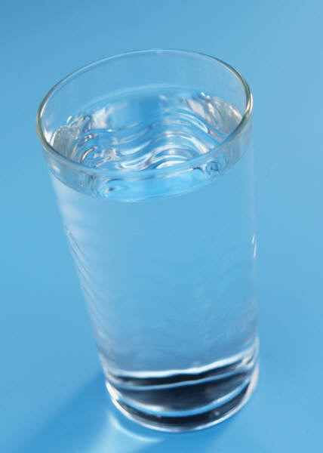

Notes: Teacher should bring out the notion that in science, we often use different models or different types of representation to convey our ideas. In order to make our ideas clearer and easier to understand, we will focus on something relevant while neglecting something insignificant. This is illustrated by a comparison of two models of the circulatory system of the blood.

Q3 In the spaces below, draw pictures to illustrate the arrangement of water molecules in solid, liquid and gas states.

ice water steam
(Notes: Teachers will need to ascertain the value of the models that students have learnt in their junior forms.)

Q4 In what ways do the drawings you have made act as models for the three states of water?
Each sphere represents a water molecule. The arrangement of the spheres shows the differences in the arrangement of water molecules in the three states. The arrangement explains the differences in the properties of three states.

Q5 Explain why it is not necessary, for instance, to use the space-filling model to describe the three states of water.
To explain the three states of water, the most important information is the arrangement of the water molecules. In this case, the information shown by a space-filling model (e.g. relative size of different atoms, composition of water molecule) becomes far less important and may distract people’s understanding.

Q6 Suggest a concept which would require a ball-and-stick or a space-filling model of water to more accurately represent it.
Ball-and-stick model: bond angles
Space-filling model: relative size of atoms

Notes: In order to better understand the properties of water resulting from hydrogen bonds between water molecules e.g. surface tension, high boiling point, high specific heat capacity, the bonding and constituents of water molecules become important. So we could use a ball-and-stick model of the molecules rather than representing water molecules as spheres.

Q7 What have you learnt from this activity about the uses of different models?
In order to understand the three states of matter (e.g. ice, water, steam), we use spheres to represent water particles. In this model, the composition of each sphere is not our concern. It is not important and may be distracting to our understanding of the arrangement of particles in different states.

Notes: As a round up, teacher might present a sphere and a space-filling model and emphasize that on different occasions, each of these have different strengths and weaknesses.
The strengths and weaknesses of a model depend on the context or purpose.

Activity 3

Which model is the best?
Key ideas: (i) Models are not copies of reality. (ii) Different models give us different pieces of information. We will have a more complete picture when putting the ideas gained from different models together.
Here are different models of a methane molecule.
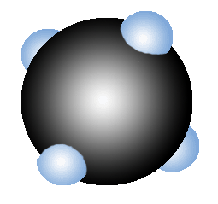  1. | 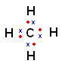  3. | 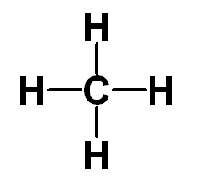  5.  Notes: Teacher may ask students, e.g. in the form of a class vote, among the different models, which one is more similar to what they perceive to be a methane molecule and why.
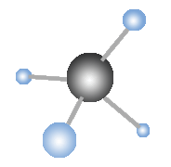  2. | 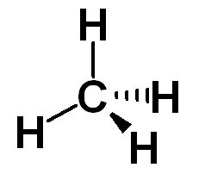  4. | 6.  CH₄
Q8 In a group of 3-4, compare the information that each model tells and does not tell you.
 | Information conveyed | Drawbacks
- Space filling | The relative size of different atoms (it shows covalent radii).  A space-filling model is particularly useful when considering steric hindrance in S_{N} reactions. | Atoms or molecules are not hard spheres.
- Ball-and  -stick | Good three-dimensional representation. Bond angles can be shown more clearly. | Sometimes, the balls are of the same size; the bond length and bond order may not be represented accurately.
- Dot-and-  cross  diagram | Number of outermost shell electrons involved in chemical bonding. Bond order. | open
- 3D diagram | The spatial arrangement of atoms can be shown in a piece of paper (i.e. in 2D) without the trouble of building space-filling and ball-and-stick model. | open
- Structural formula | Bond order (single, double or triple bond); the structure of a molecule (i.e. which atom is bonded to which atoms). | open
- Chemical formula | The atoms and their number in a molecule. It is a very convenient shorthand to represent a molecule, particularly when the molecule is made of many atoms (e.g. C₆H₁₂O₆ is more convenient and simpler than it structural formula). | open

Q9 Can we have a true picture of a methane molecule when we put the information from all these models together?
Even seeing all of these models all together cannot constitute a complete representation of the molecules or a real methane molecule. For example, the nuclear structure (e.g. the number of neutrons), the size of the nucleus and the movement of electrons have not been considered.
Models are not copies of reality.

Further Exercise/ Homework Exercise

Task 1
Construct a table to compare the strengths and weaknesses of each model of sodium chloride.
  - 2D picture of NaCl (showing the relative size of Na⁺ and Cl⁻)
  - A 3D model of a NaCl lattice
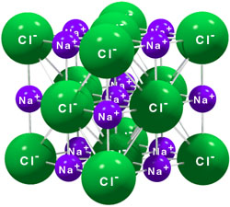
  - The formula ‘NaCl (s)’
Notes: Some students hold the view that each sodium ion is bonded to six chloride ions. This may be due to their literal interpretation of the 3D model of NaCl where they see the sticks representing the ‘ionic bonds’.

Task 2
In your view, which model is better to illustrate the digestive system in our bodies? Why?

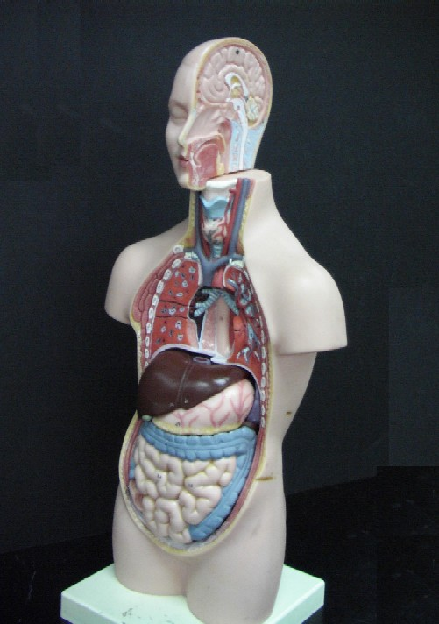
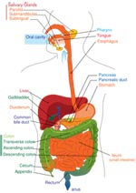

Task 3
Suggest some examples from your integrated science lessons where the teachers or the textbooks use different models to present their ideas.

Task 4 (for Form 6)
Compare the strengths and weaknesses of the shell model and the orbital model of an atom.

Appendix: Lesson plan

Activity 1: The most helpful map (Introduction to the ideas of Model and Multiple Representations)
Time | Intended Learning Outcomes | Teaching Flow | Materials | Remarks
15 min | Students should be able to  - define models  - state the multiple representations of models  - state that models usually highlight the more relevant areas while neglecting those less important | - Students compare three kinds of maps all showing MTR stations (PowerPoint slides)  - Teacher probes students about what they perceive to be the “best” map.  - Key questions: Which type of map do you think is the best?  - Teacher may bring out the idea that ‘best’ can be defined in terms of either how similar the model is to reality or how useful the model is.  - Teacher brings out that model can be regarded as a representation of an idea, an event, a process or a system.  - Students discuss the necessity of drawing everything they seen on a map.  - Teacher brings out that when developing a model, it is most common that people will selectively highlight the more relevant areas while neglecting something less important. | - PowerPoint (slides 2 – 15)  - Worksheet

Activity 2: The three states of water (Linking the concepts discussed in Part 1 to Science)
Time | Intended Learning Outcomes | Teaching Flow | Materials | Remarks
15 min | Students should be able to  - appreciate the use of different models in science  - point out that the strengths and weaknesses of a model depend on the context or purpose  - value different types of models in aiding understanding in junior and senior forms | - Teacher shows two models of the circulatory system (in the PowerPoint).  - Students draw pictures to illustrate the arrangement of water particles in solid, liquid and gas state.  - Students discuss the reasons for using spheres to represent water particles.  - Teacher points out that the strengths and weaknesses of a model depend on the context or purpose.  - Teacher would ascertain the value of model that students learn in their junior forms- they are not wrong, but serve different purposes. | - PowerPoint (slides 16 – 21)  - Worksheet | We should not judge a model that students learn in their earlier stage of study (e.g. particles as spheres) to be ‘wrong’. While these models may suffer from their breath of explanation, they have an apparent advantage of simplicity and serve good purpose.

Activity 3: Which model is the best? (A reexamination of different chemical models)
Time | Intended Learning Outcomes | Teaching Flow | Materials | Remarks
35 min | Students should be able to  - work out the benefits and drawbacks of different models  - point out that Models are not copies of reality  Further Exercise  (To reinforce or assess students’ understanding to models.) | - Teacher shows methane molecules represented in different ways.  - Teacher may ask students, e.g. in the form of a class vote, among different models, which one is more similar to what they perceive to be a methane molecule and why.  - Students compare the benefits and drawbacks of each model and the information that each model conveys and does not convey. (Group discussion)  - Teacher asks students whether they have a true picture of the methane molecule when they put all the information from these models together.  - Teacher summarizes that even seeing all models of methane collectively, we cannot construct a complete representation of a real methane molecule. | - PowerPoint (slides 22 – 39)  - Worksheet | It is very important to be aware of the scope and limitation of each model. A deeper understanding can result from the comprehension of multiple representations

